# Azure Load Balancer

## **Tutorial**

### **New Resource Group**

The first thing is to create a new resource group, which we can do by clicking the burger bar in the top left corner and choosing Resource groups:

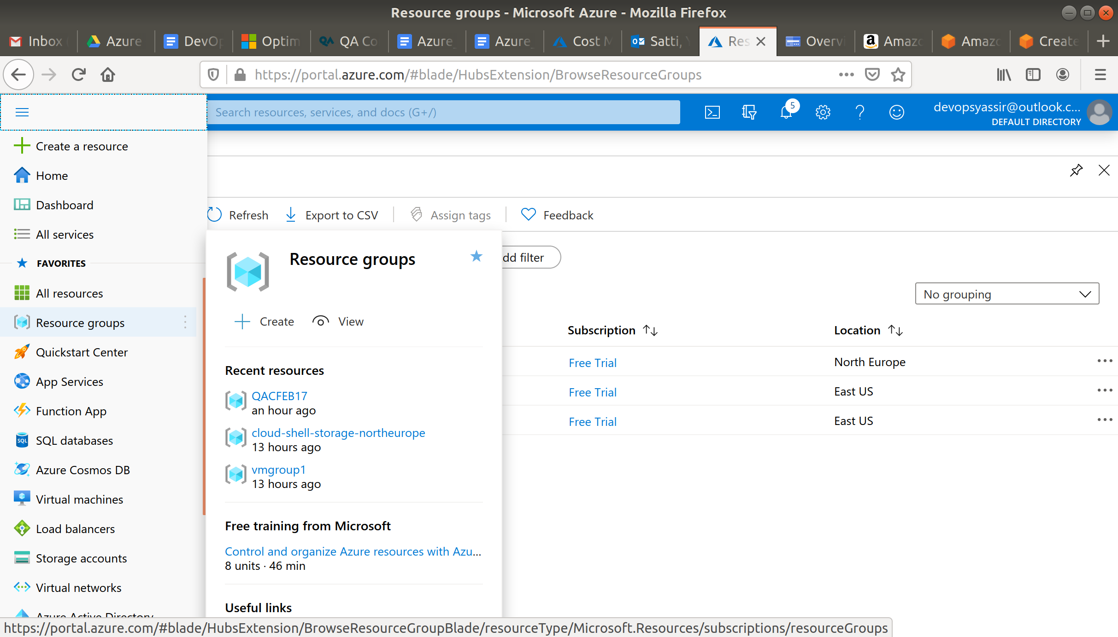

Then, we can click +Add:

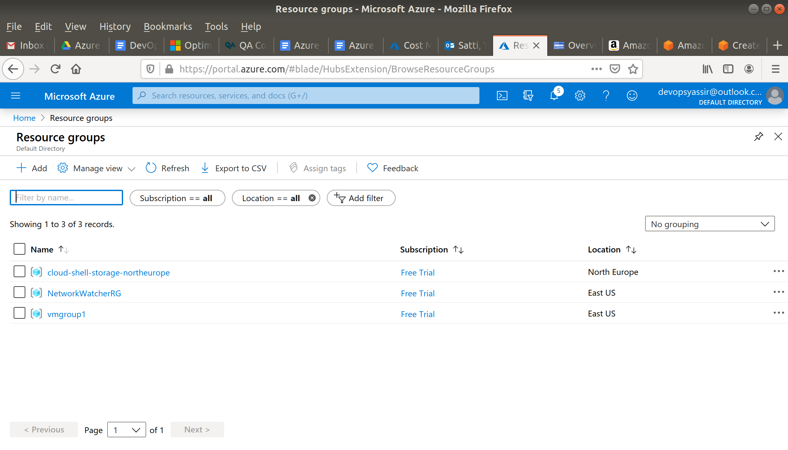

Here, we can name the resource group and pick a location to have it in:

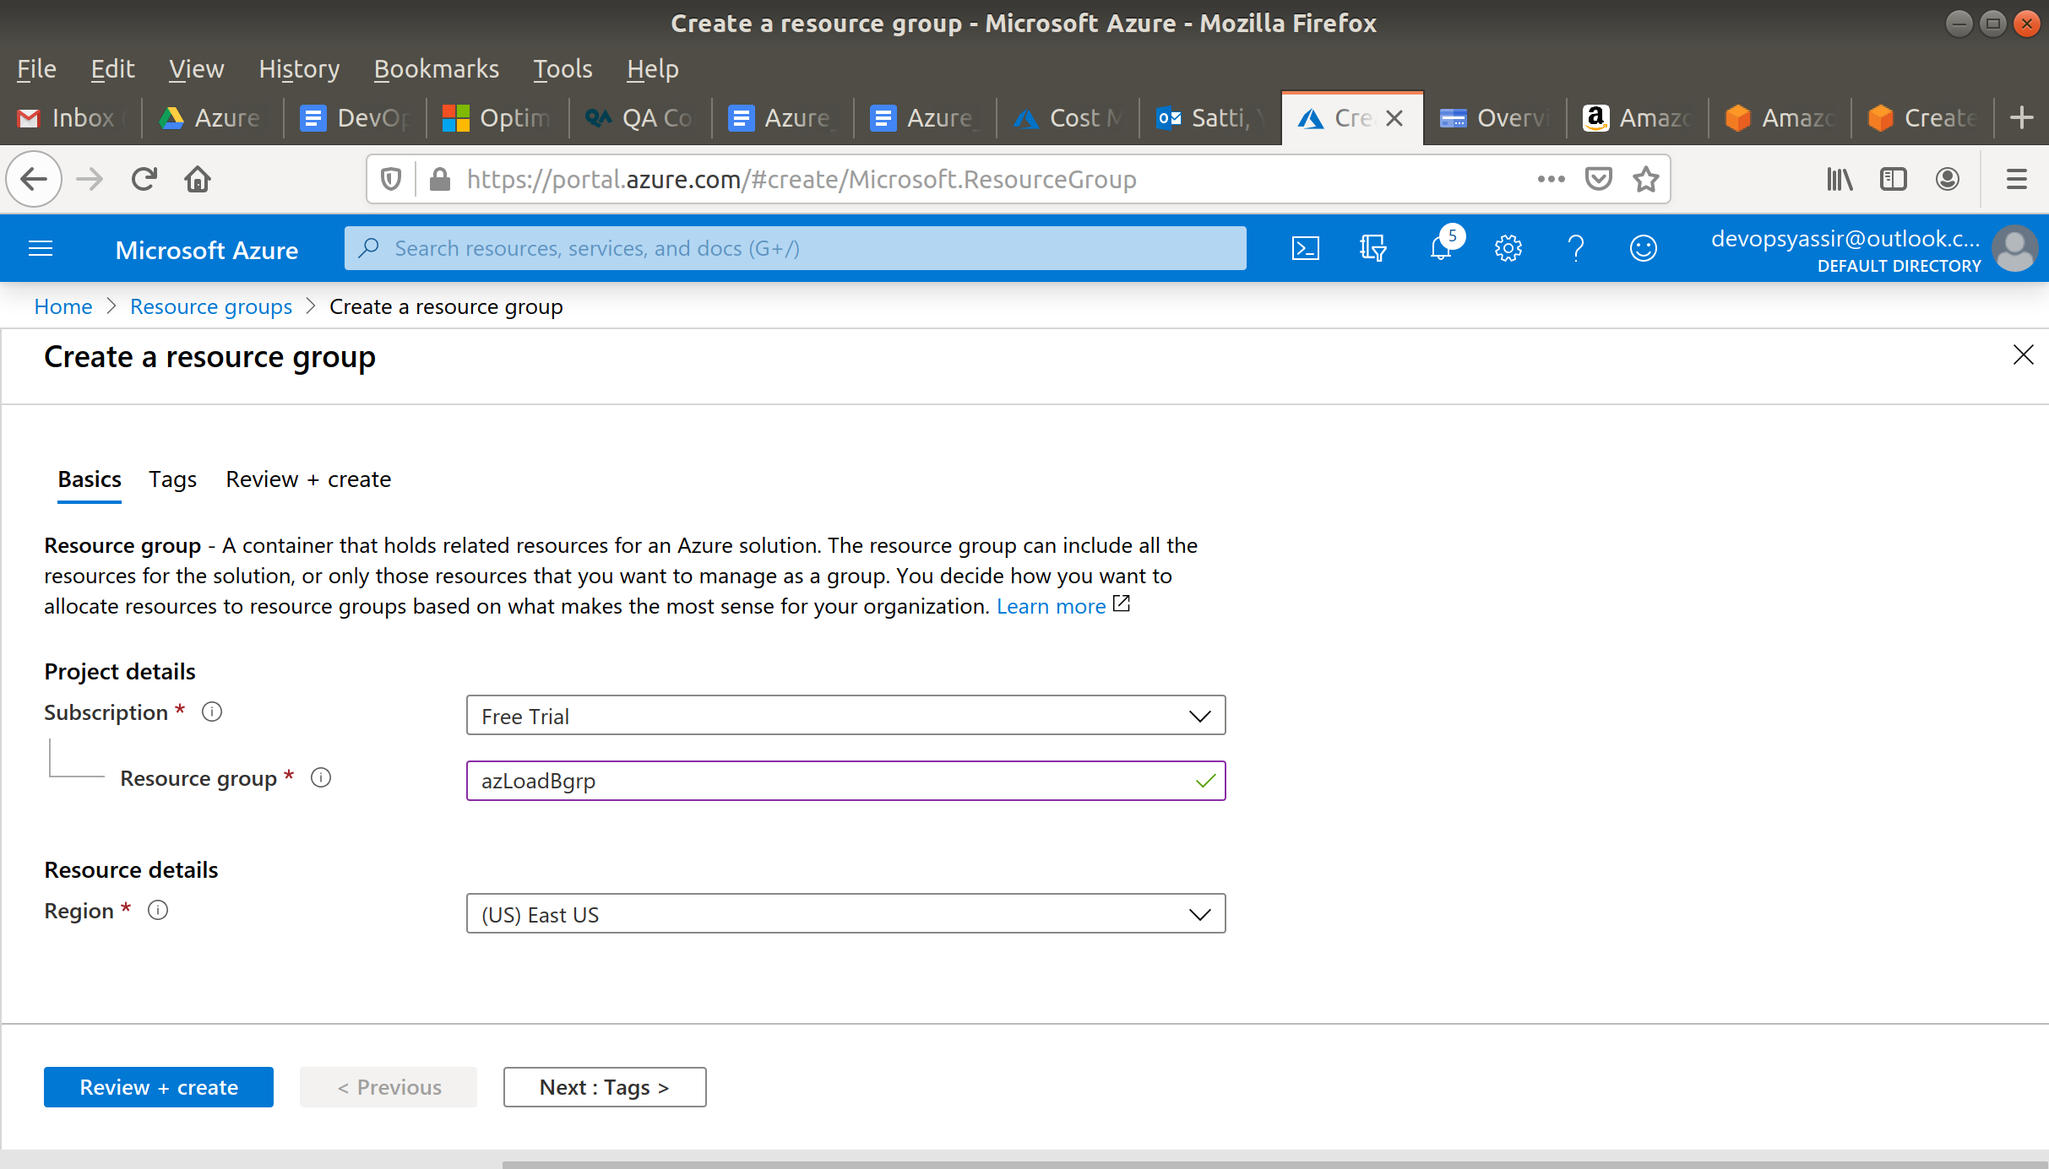

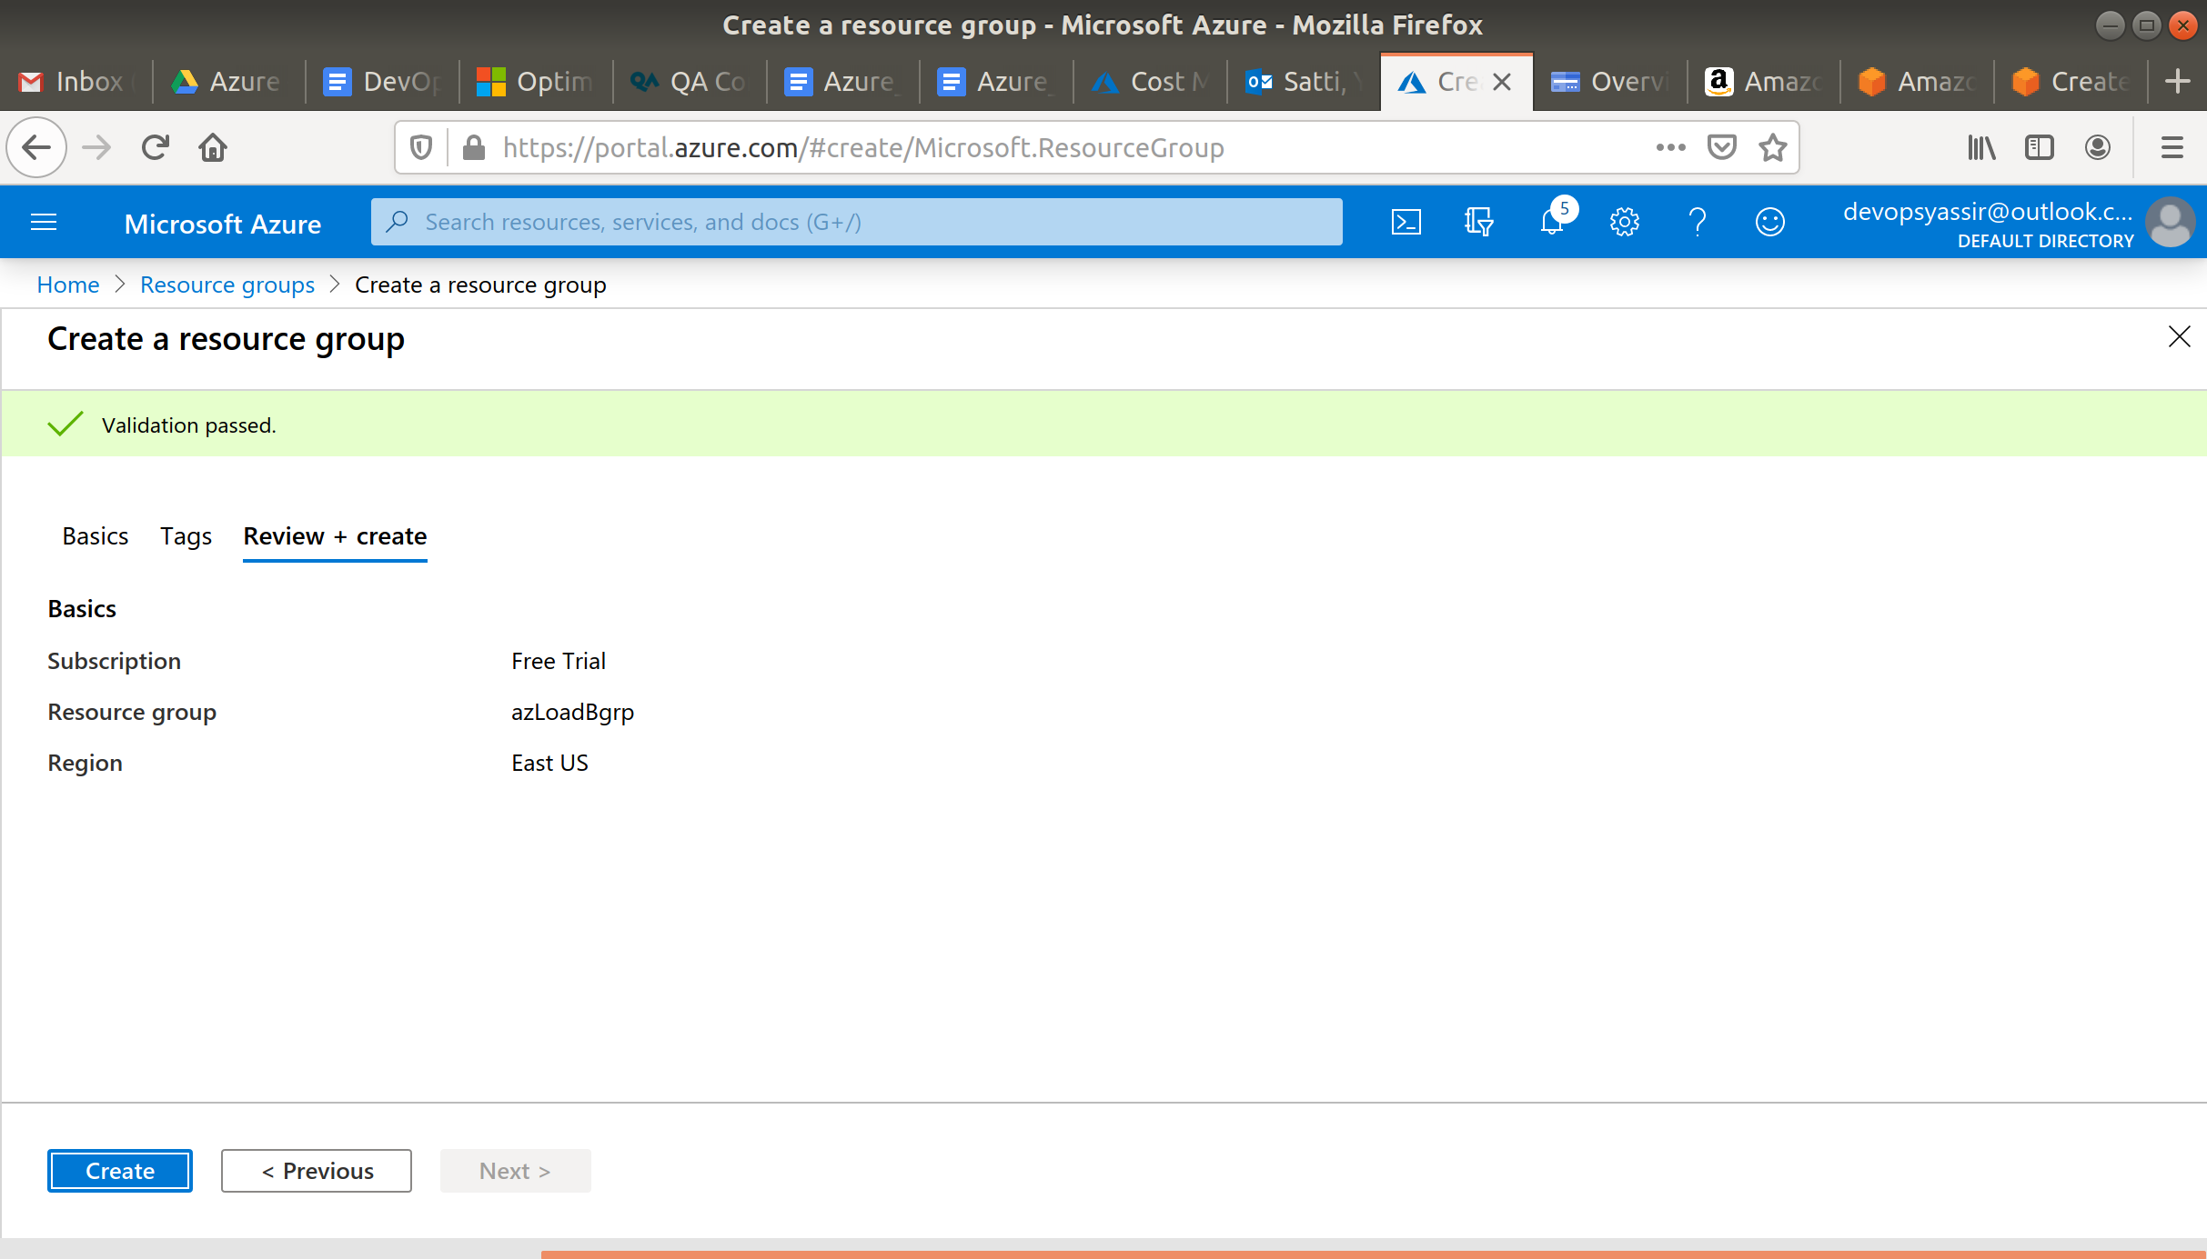

Lastly, we will click Review & Create and then Create to create the resource group:

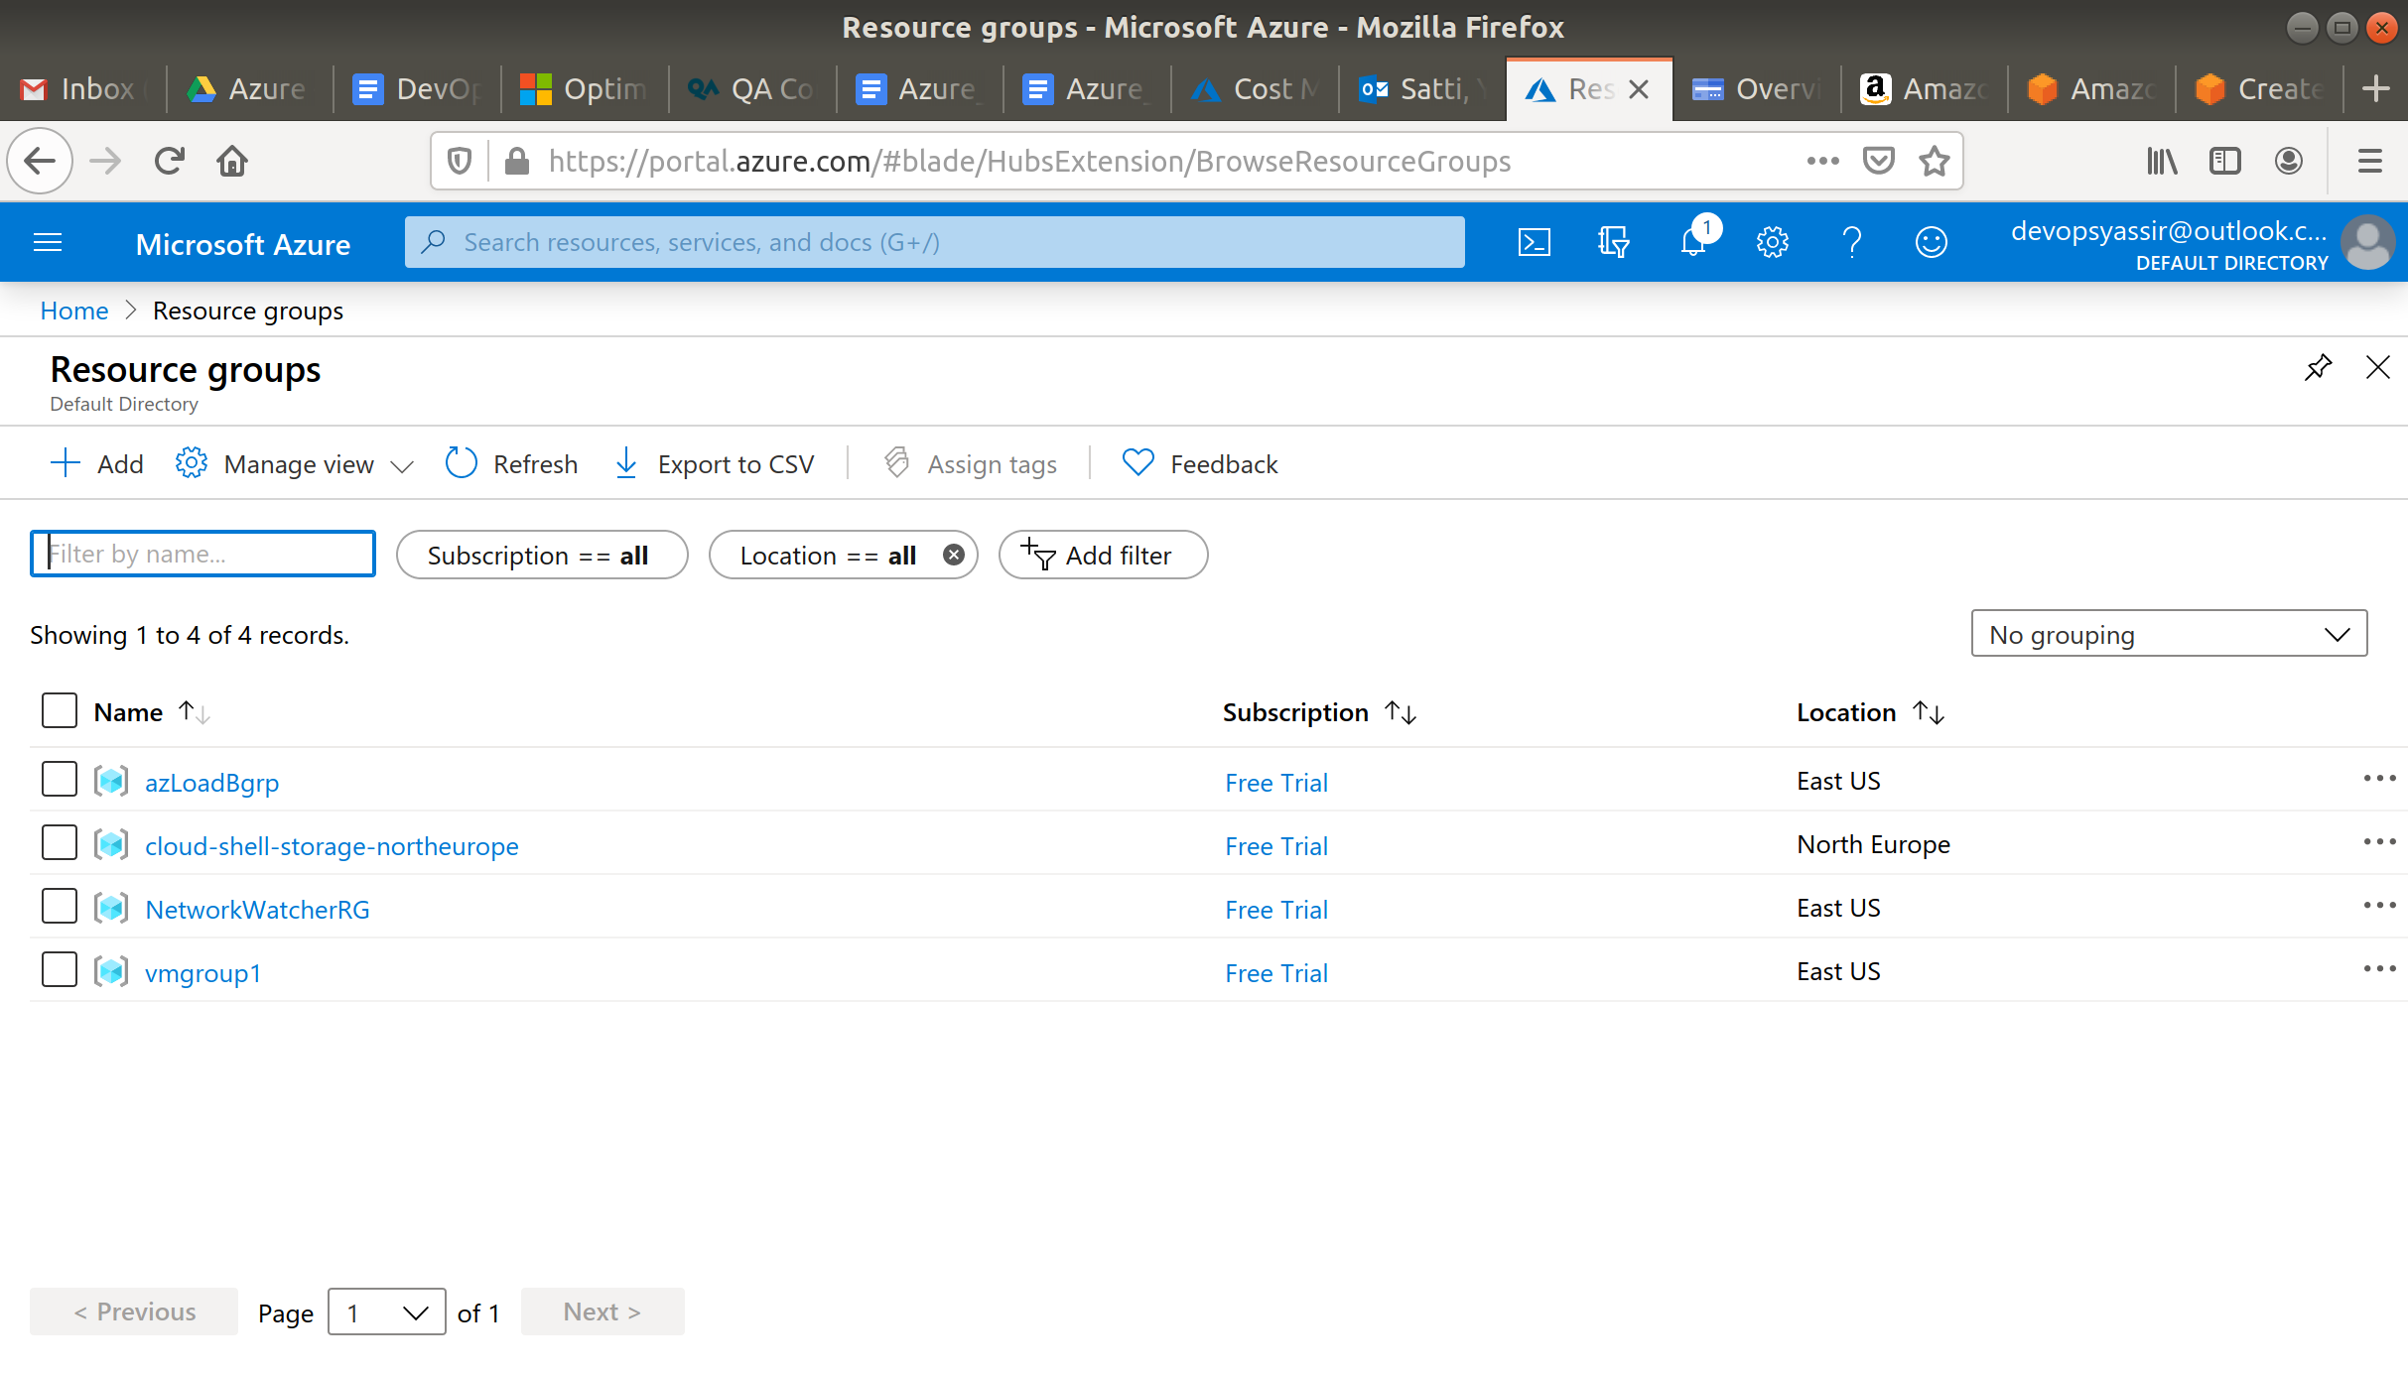

### **Creating the Load Balancer**

Click on the burger bar in the top left, and navigate to the load balancer blade.

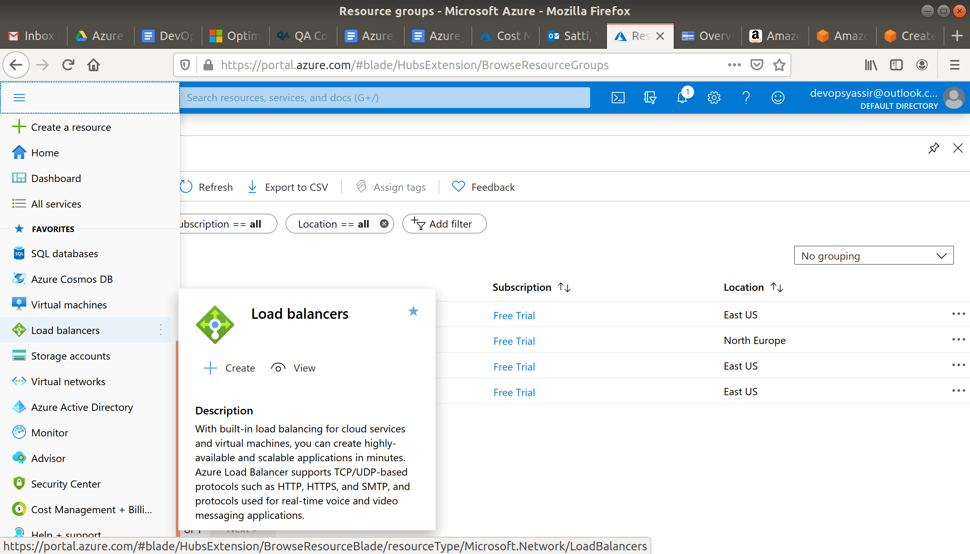

Click the + Add in the top left.

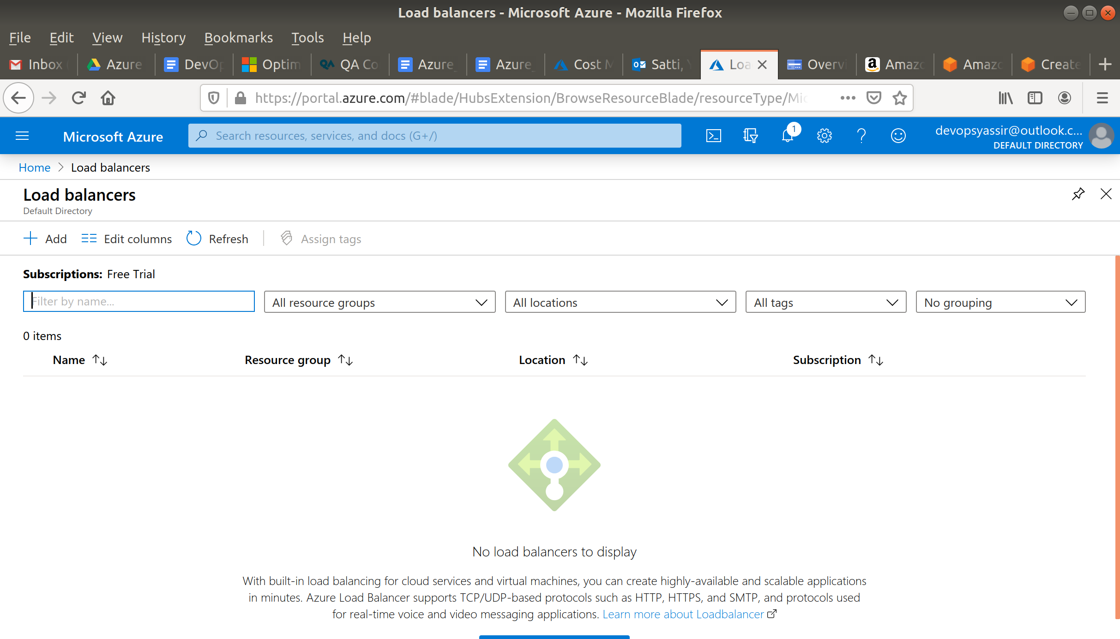

Select your resource group, call the load balancer NewLB in Europe UK South, change the SKU to **standard**, create a new Public IP with whatever name you want, chose **zone-redundant** for the availability zone and leave the rest as default.

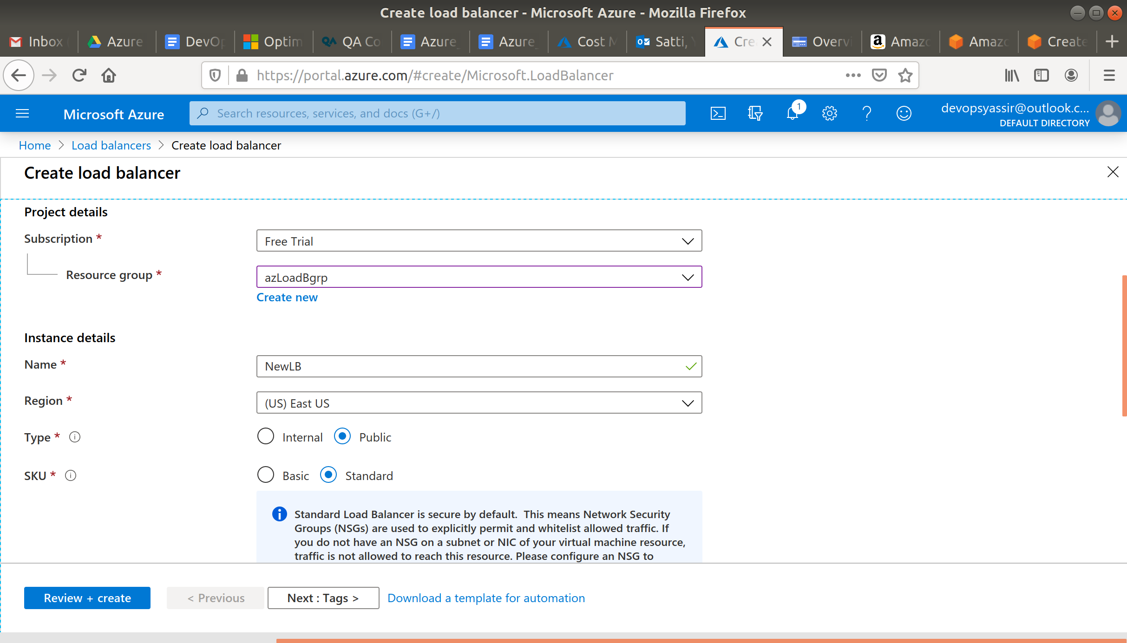

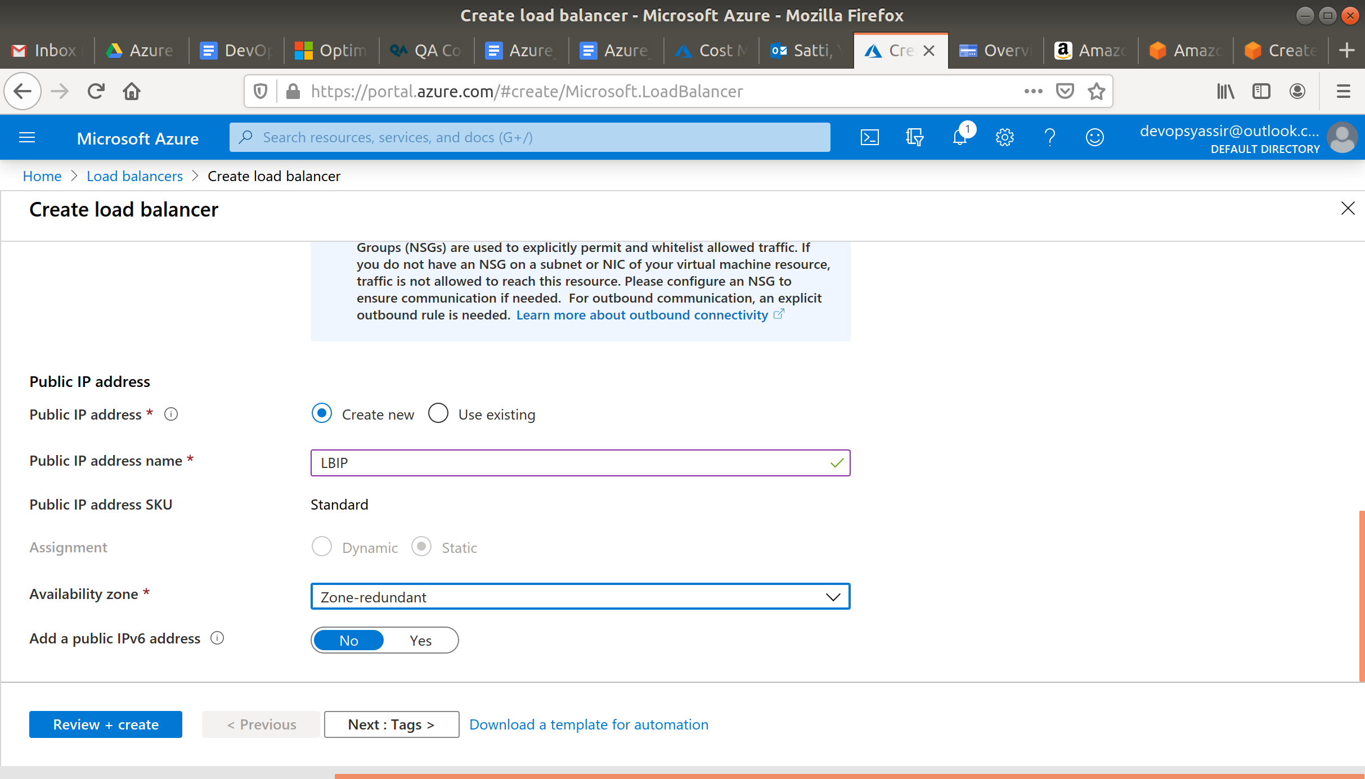

Click Review + Create, then click Create.

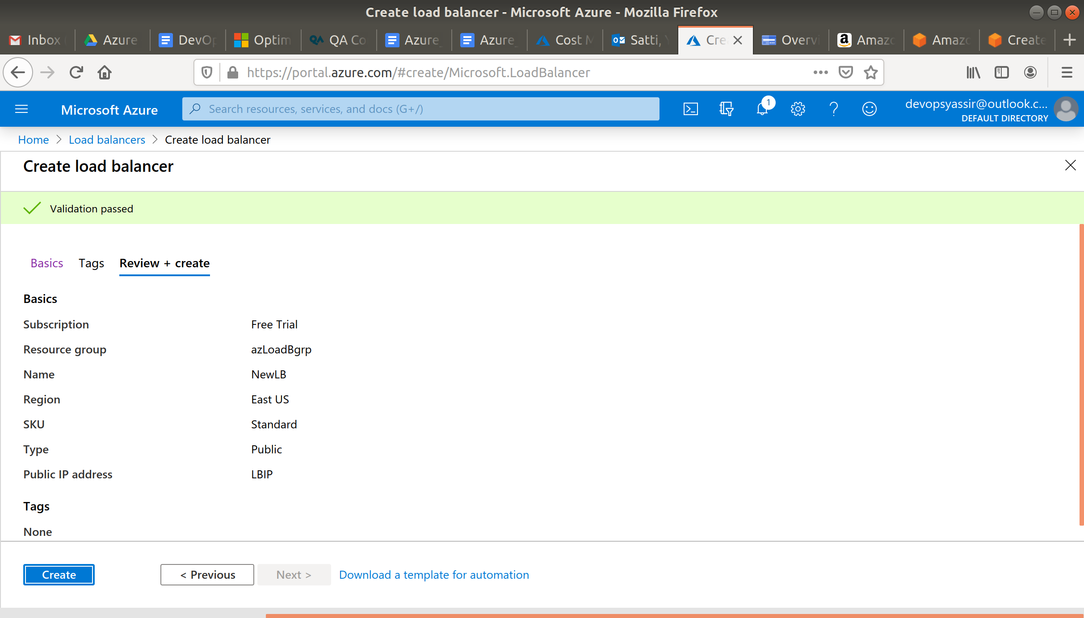

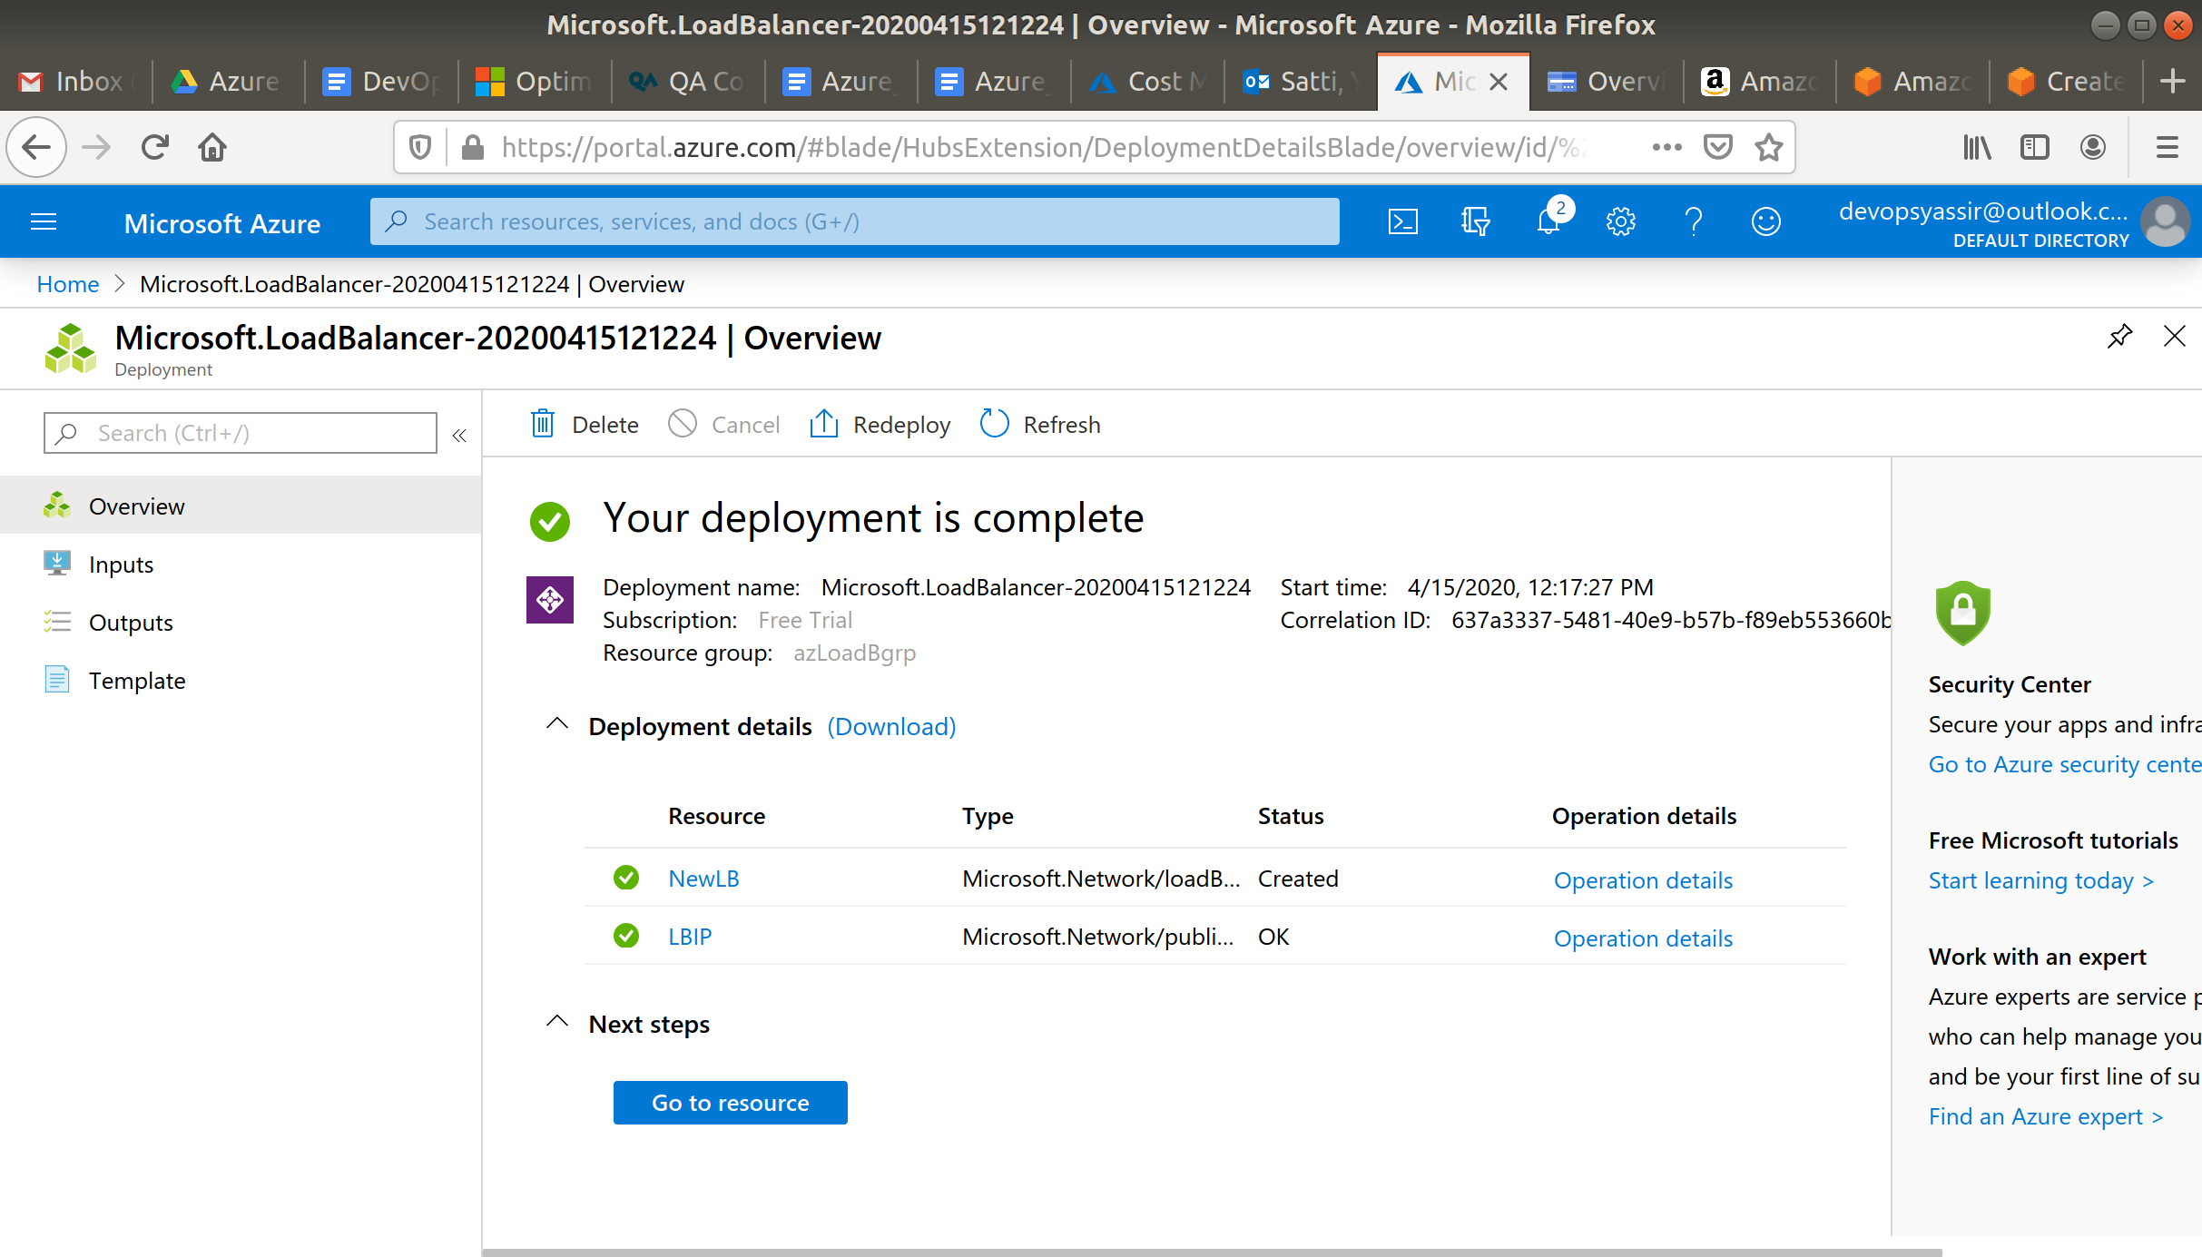

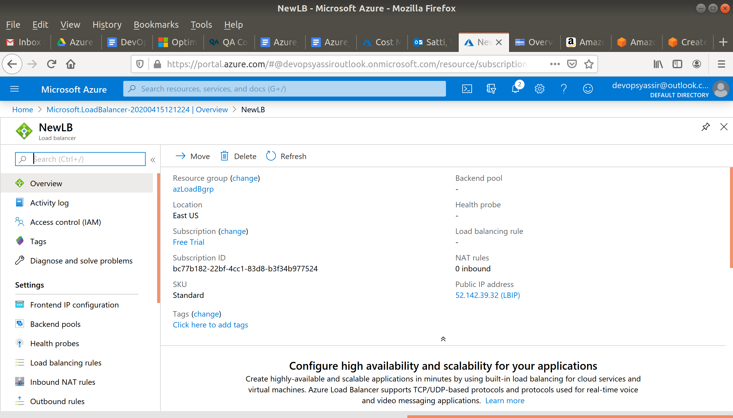

### **New Virtual Machines**

For this, we need to first go to the hamburger menu again, but this time click Virtual machines:

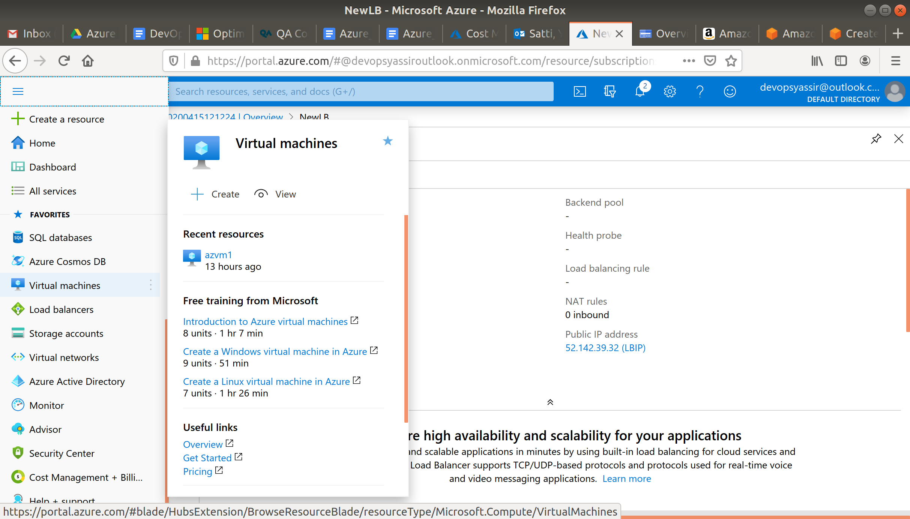

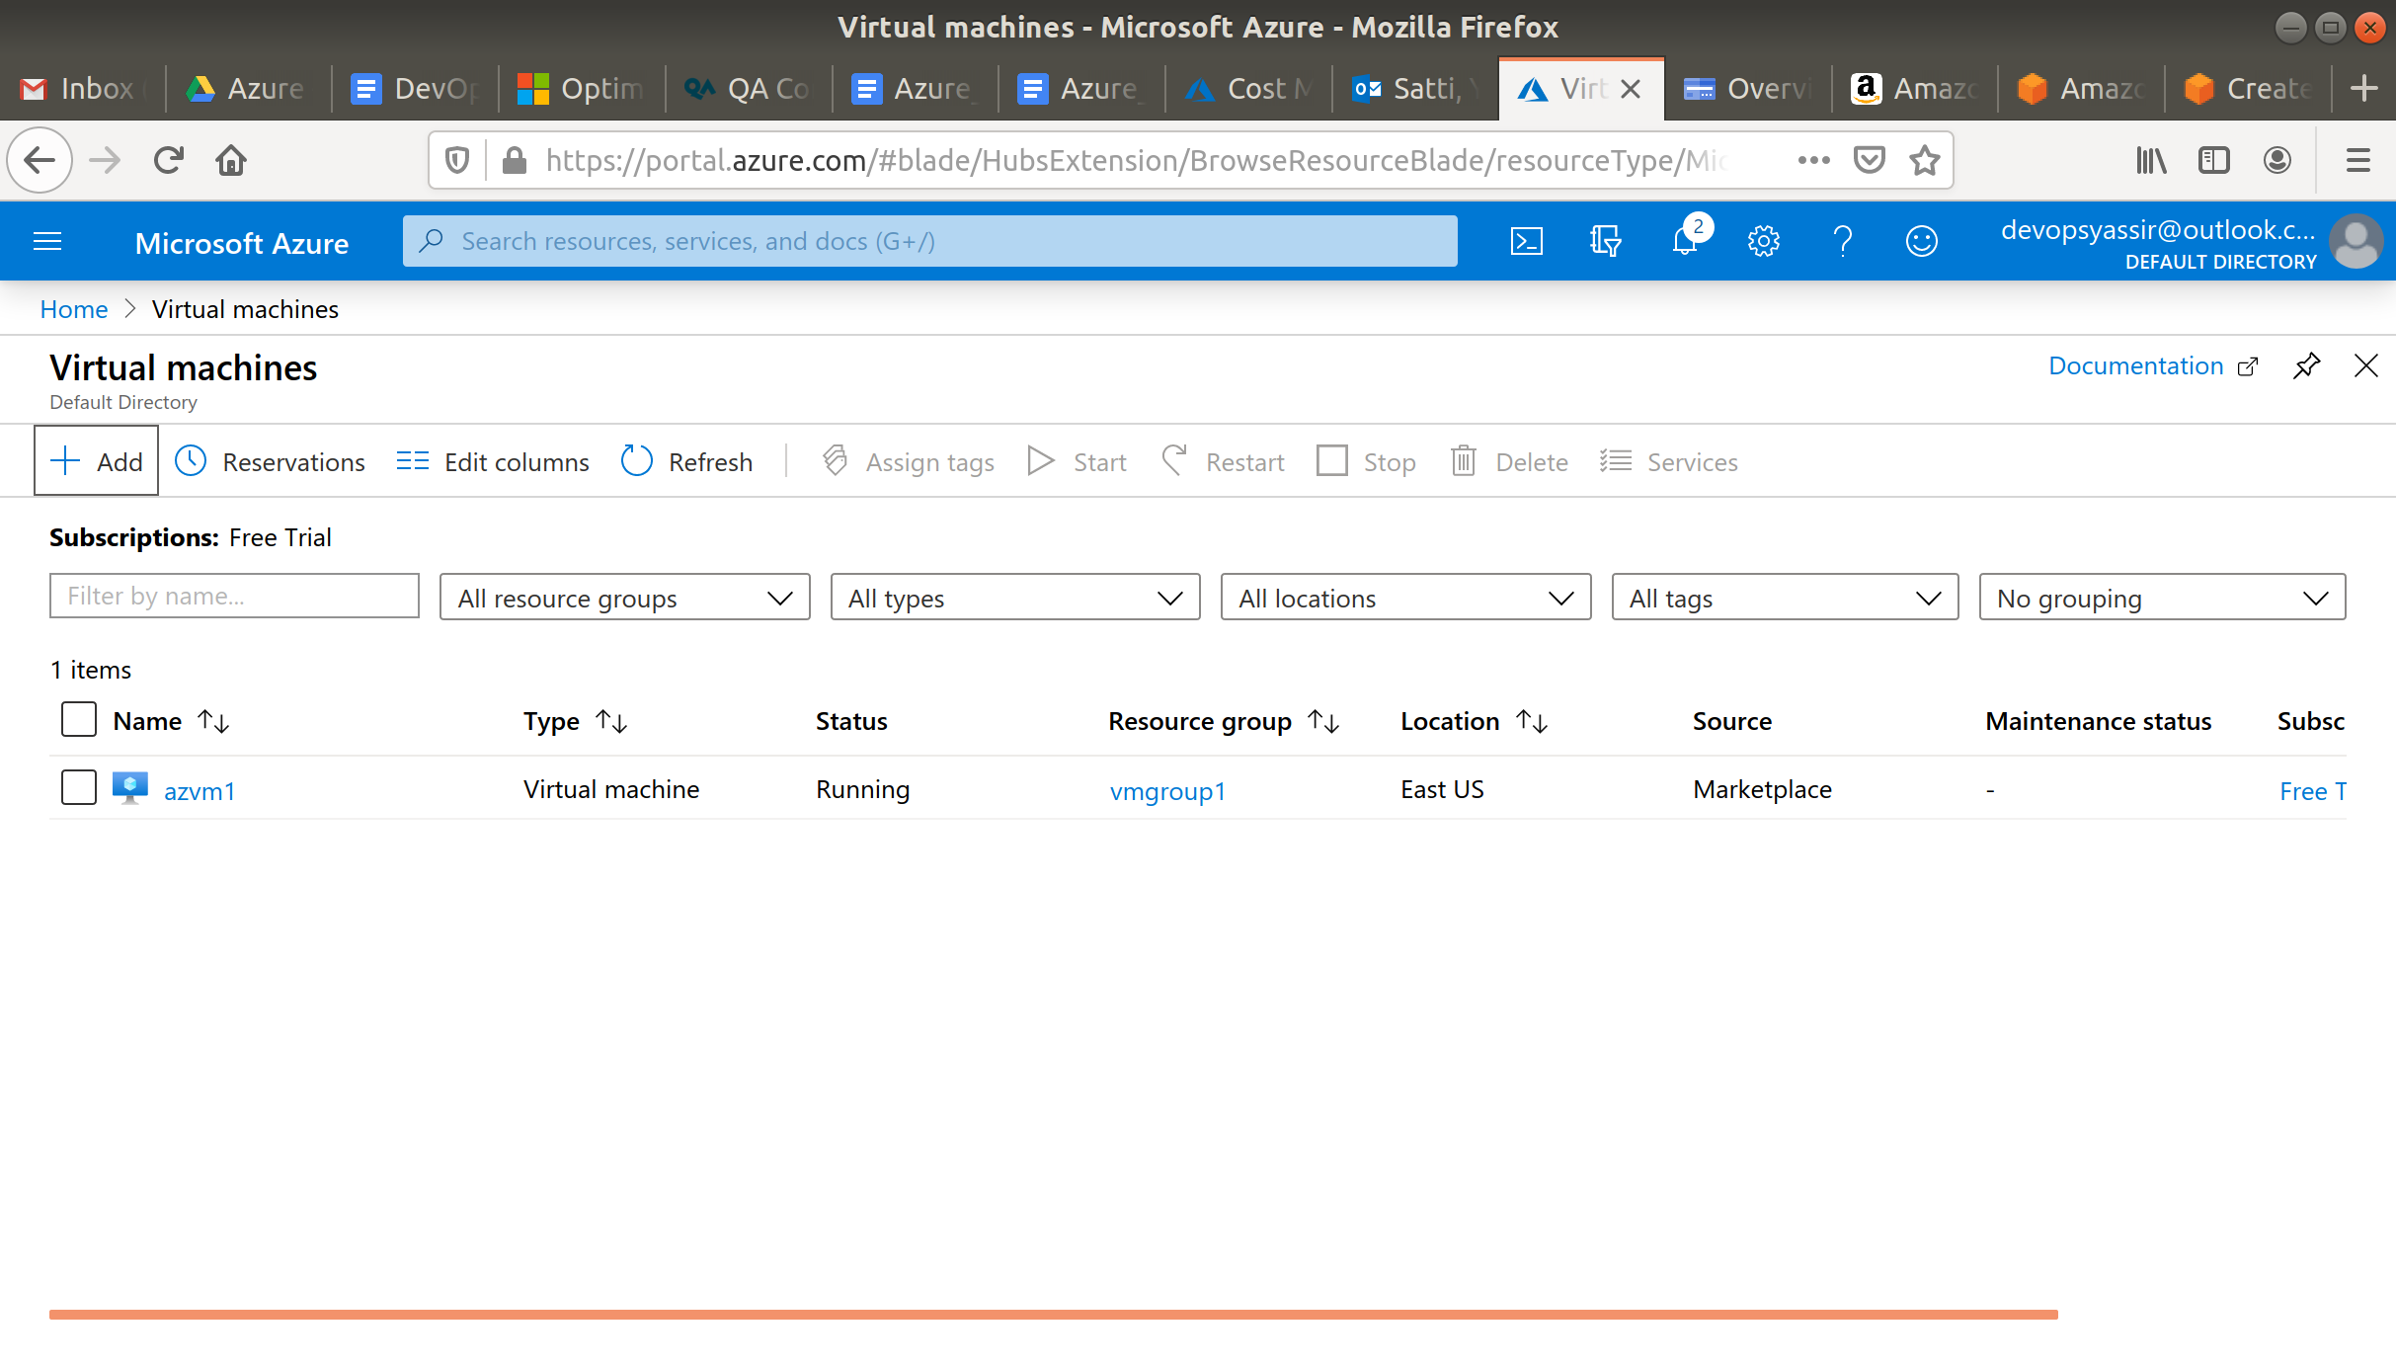

Then, we click + Add:

We will need to choose our new resource group from the drop down menu, give the machine the name **server1** and pick a region for it to be deployed into.

The image can be Ubuntu Server 18.04 LTS, and the Size can be Standard D2s v3:

We need to choose password for authentication type, and create a username and password.

We also need to ensure that Port 22 is open, so we can SSH into the machine later (this should be checked by default) and Port 80 is open, so it can be accessed via HTTP requests:

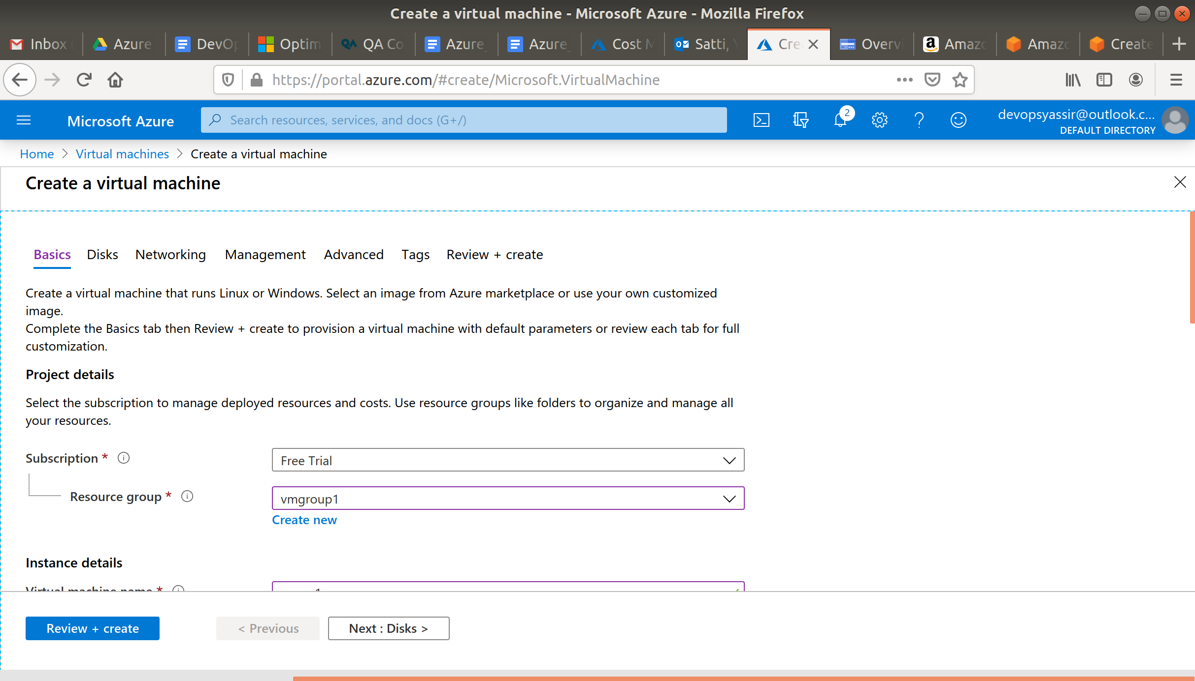

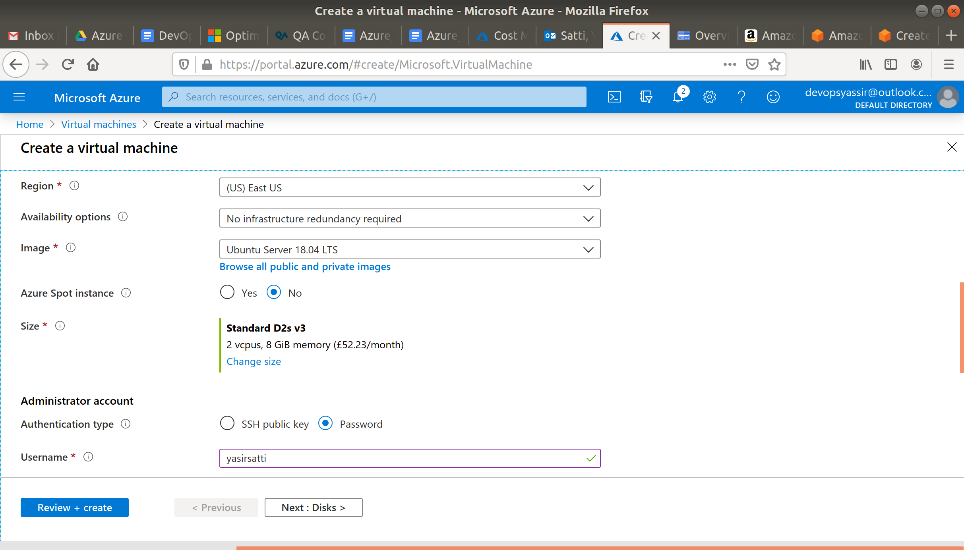



Click on Networking and scroll down to **Load balancing**.

Select the following options:

1. yes
2. Azure load balancer
3. NewLB (or the name of the load balancer you just created)
4. Create new backend pool

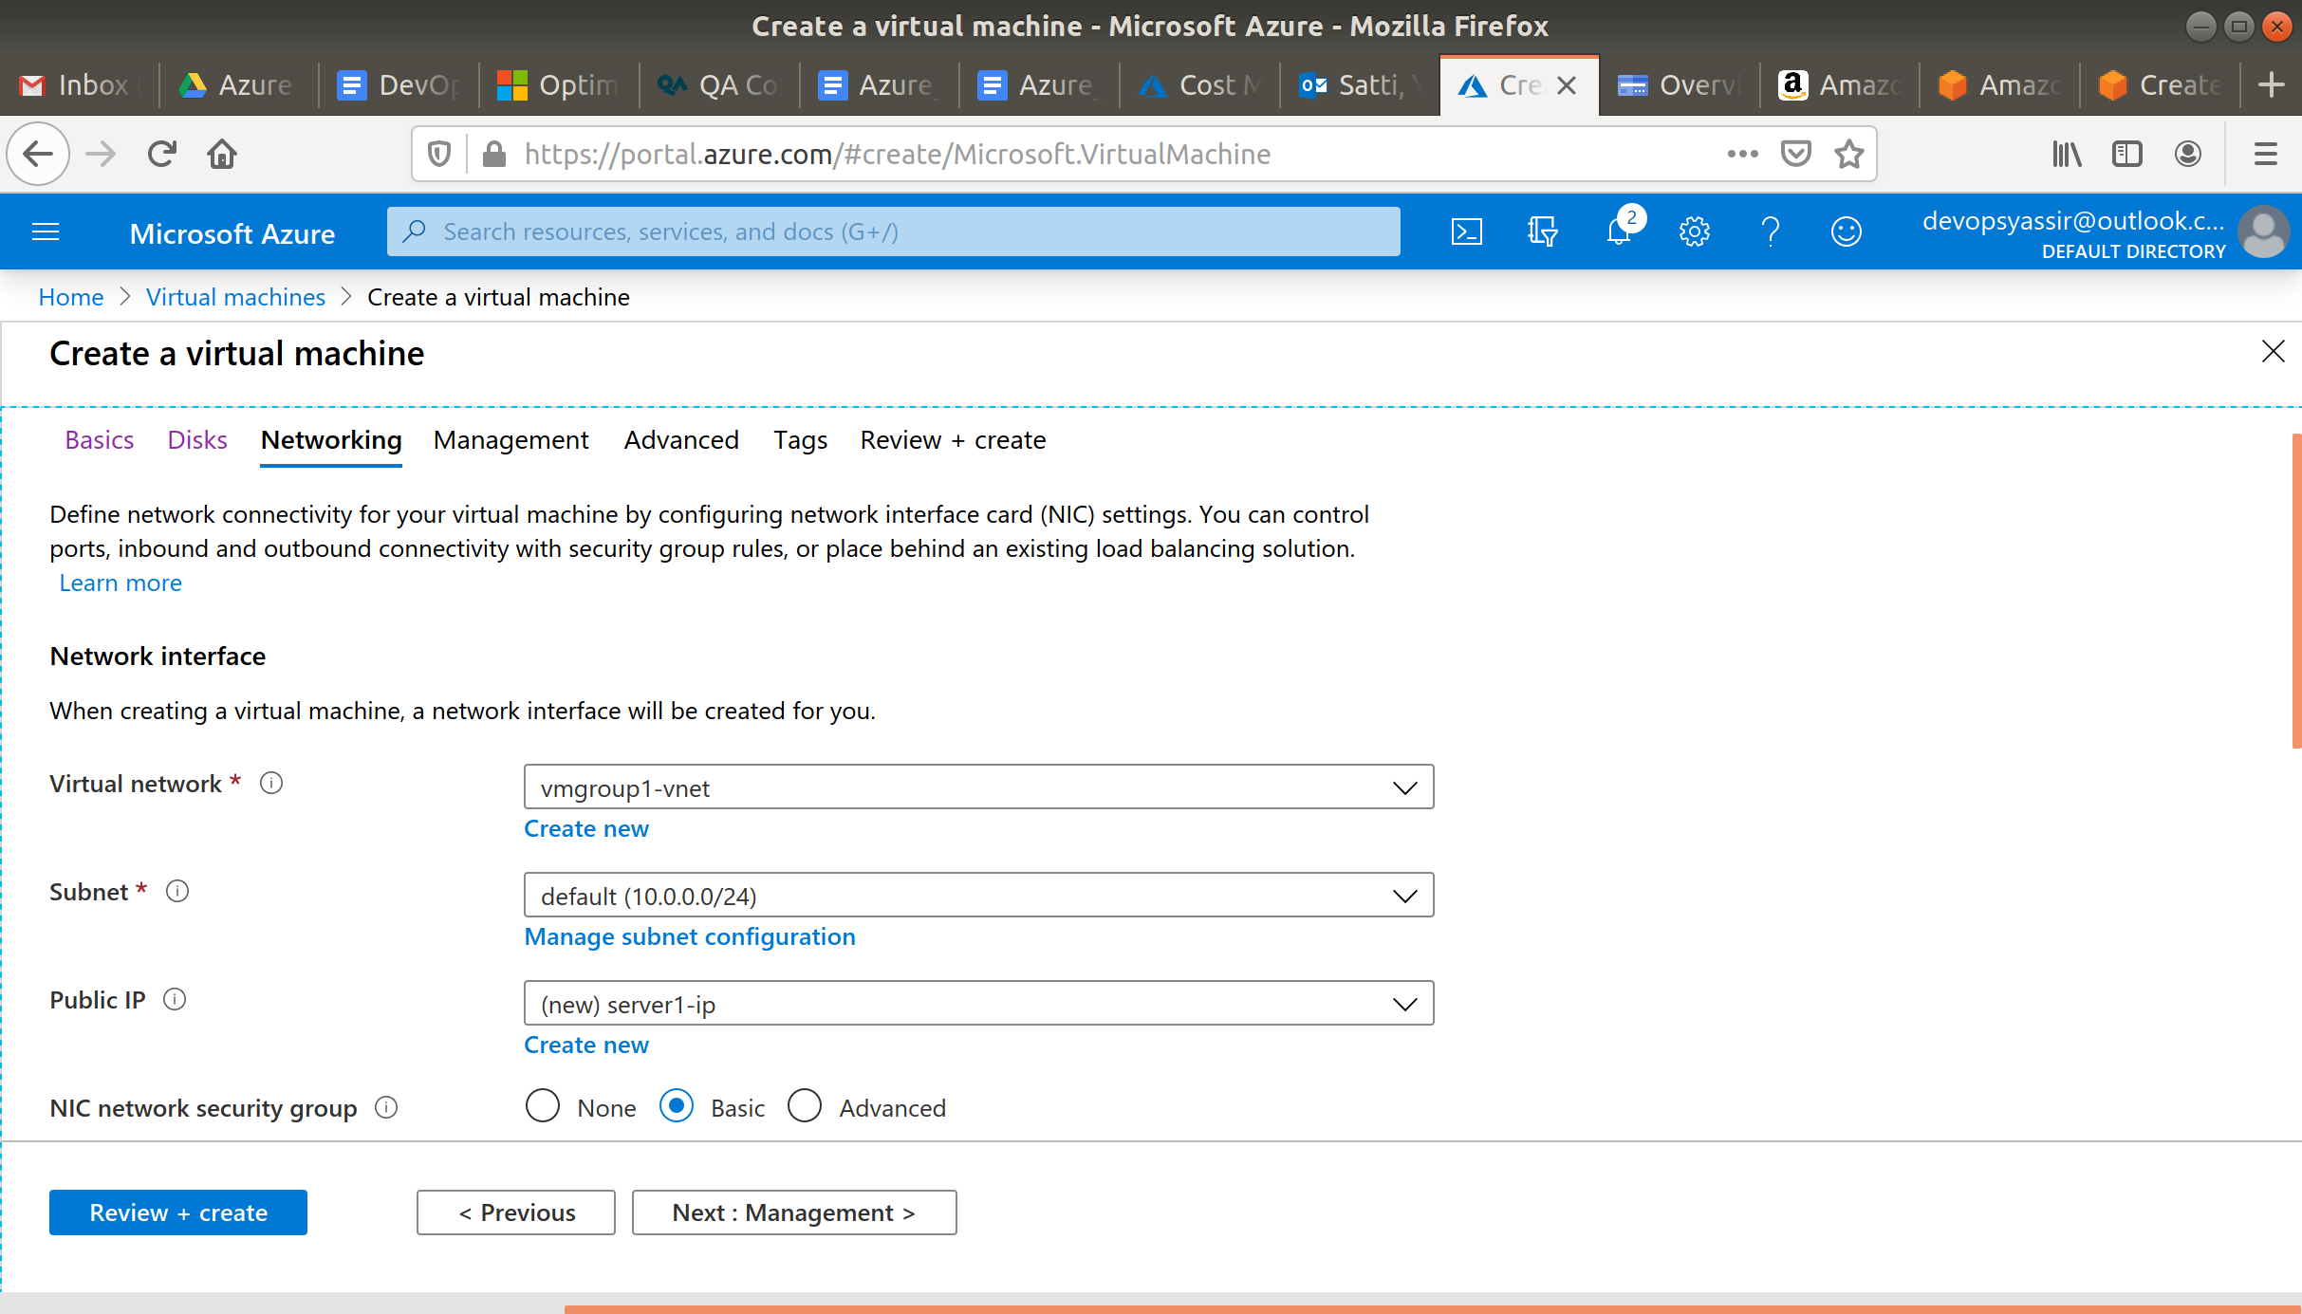

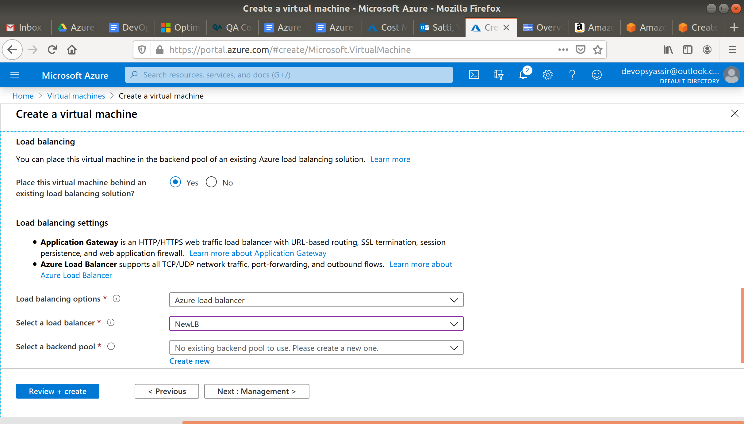

An new blade will open which will look like this, choose a name for your backend resource pool.

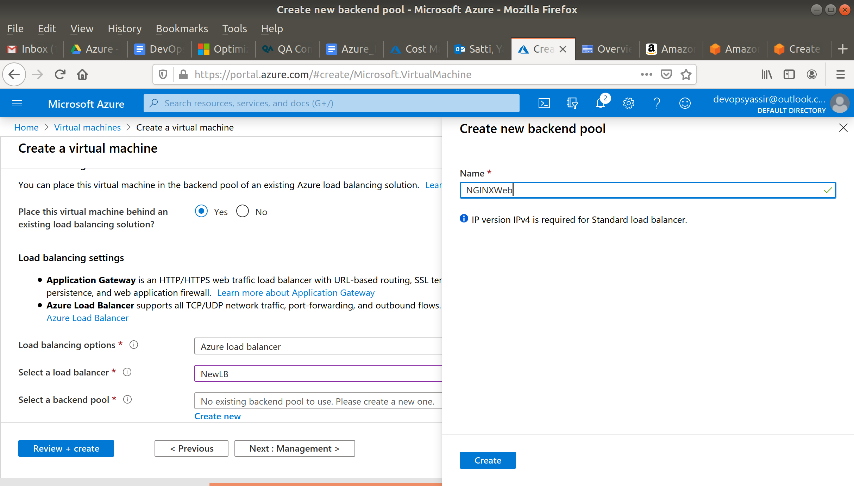

Click on Create then Review + Create.

After clicking Create, our Linux VM is created!

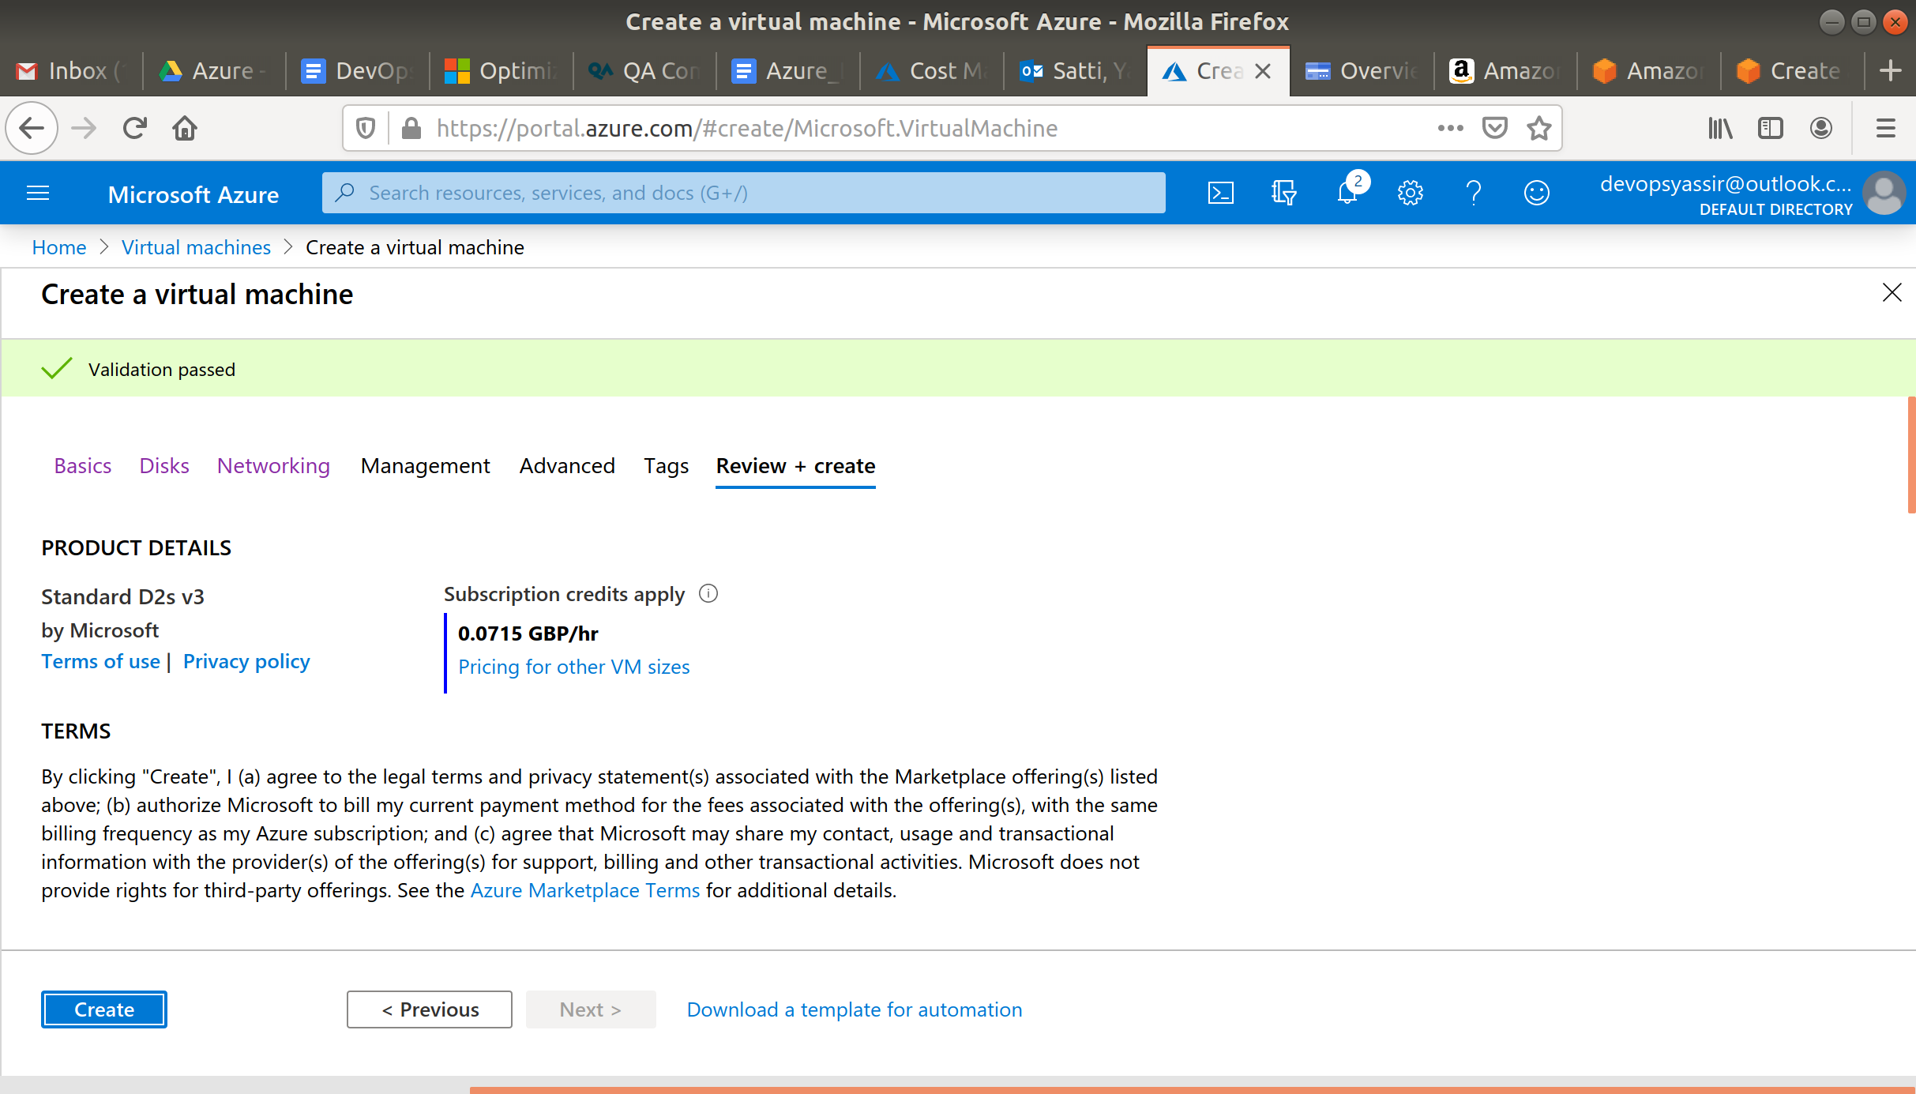

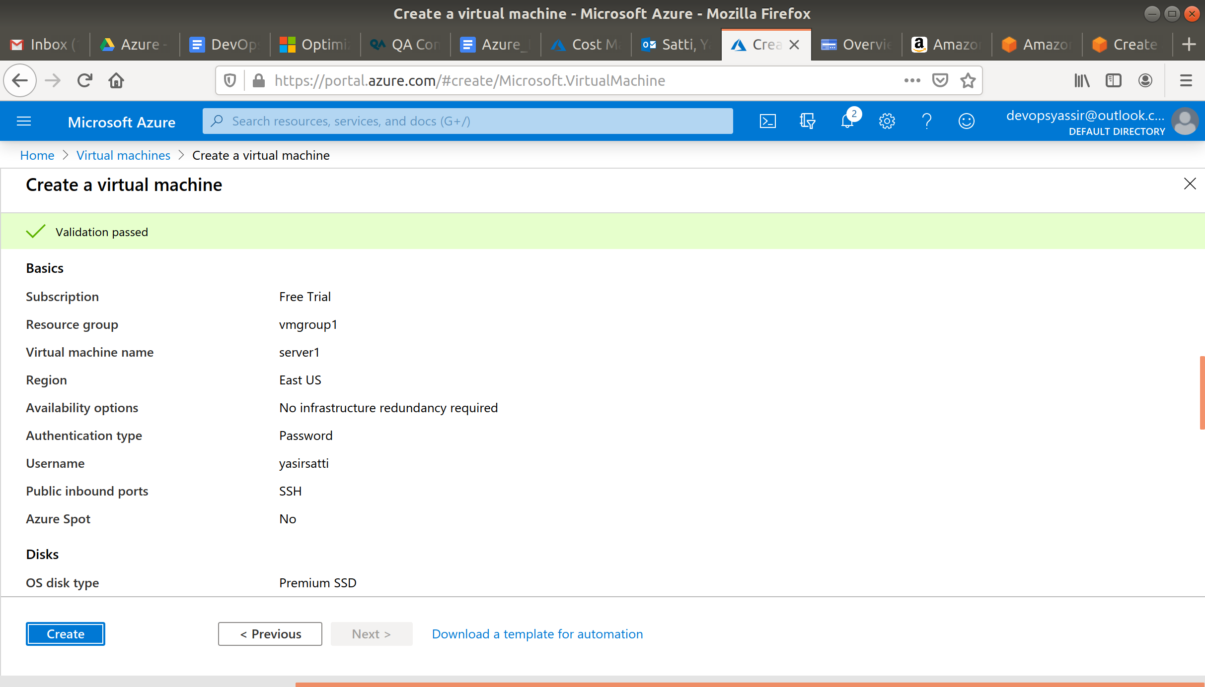

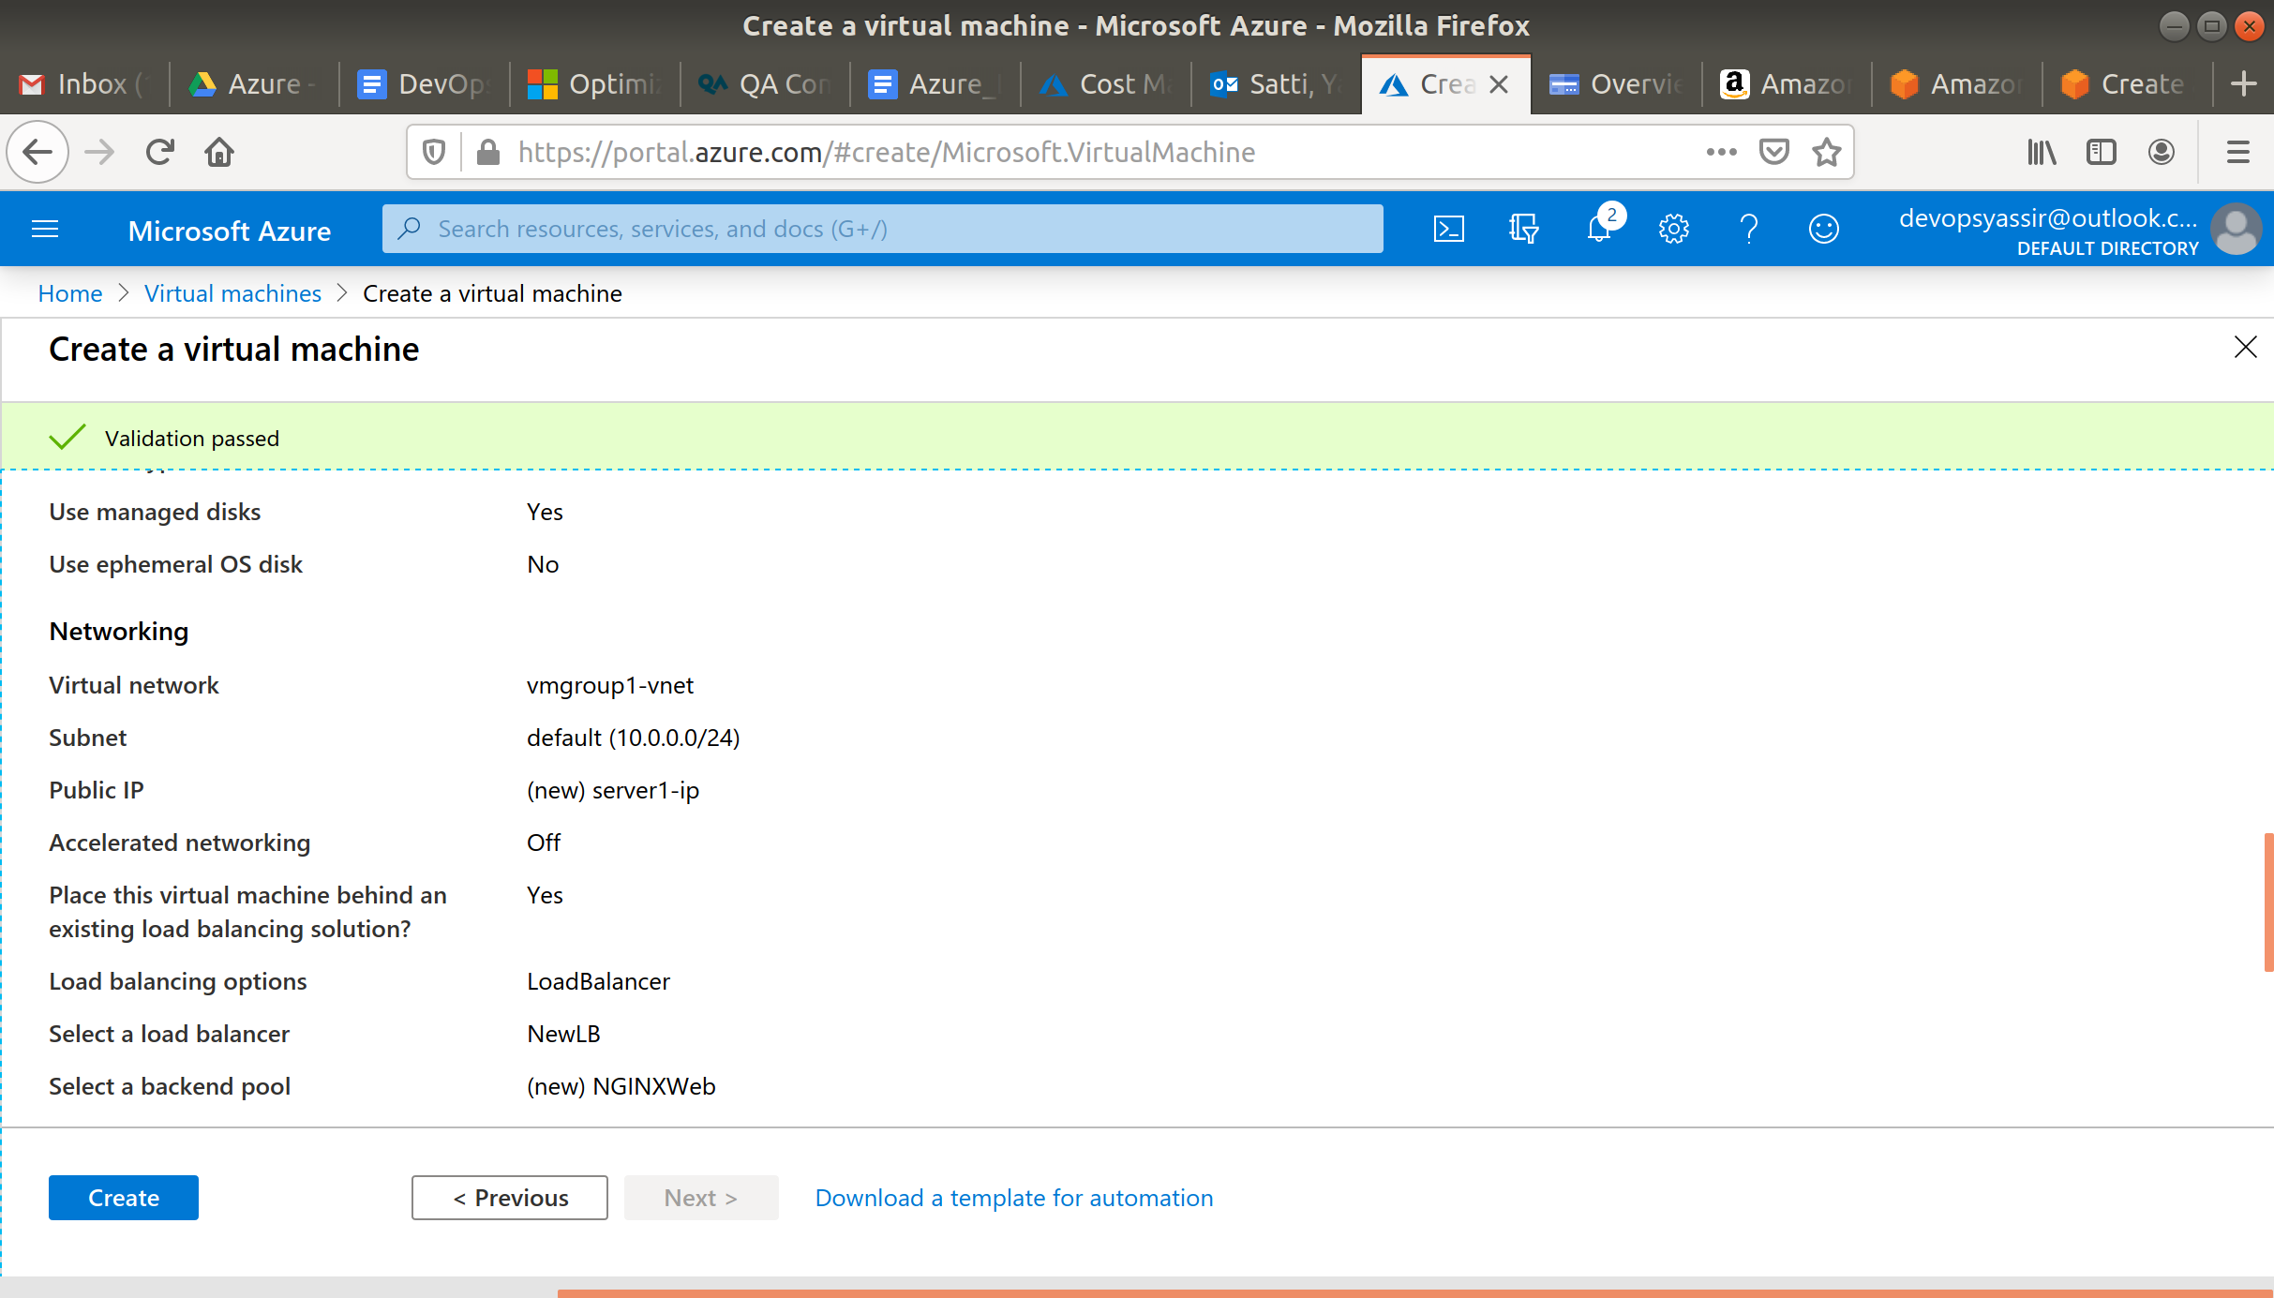

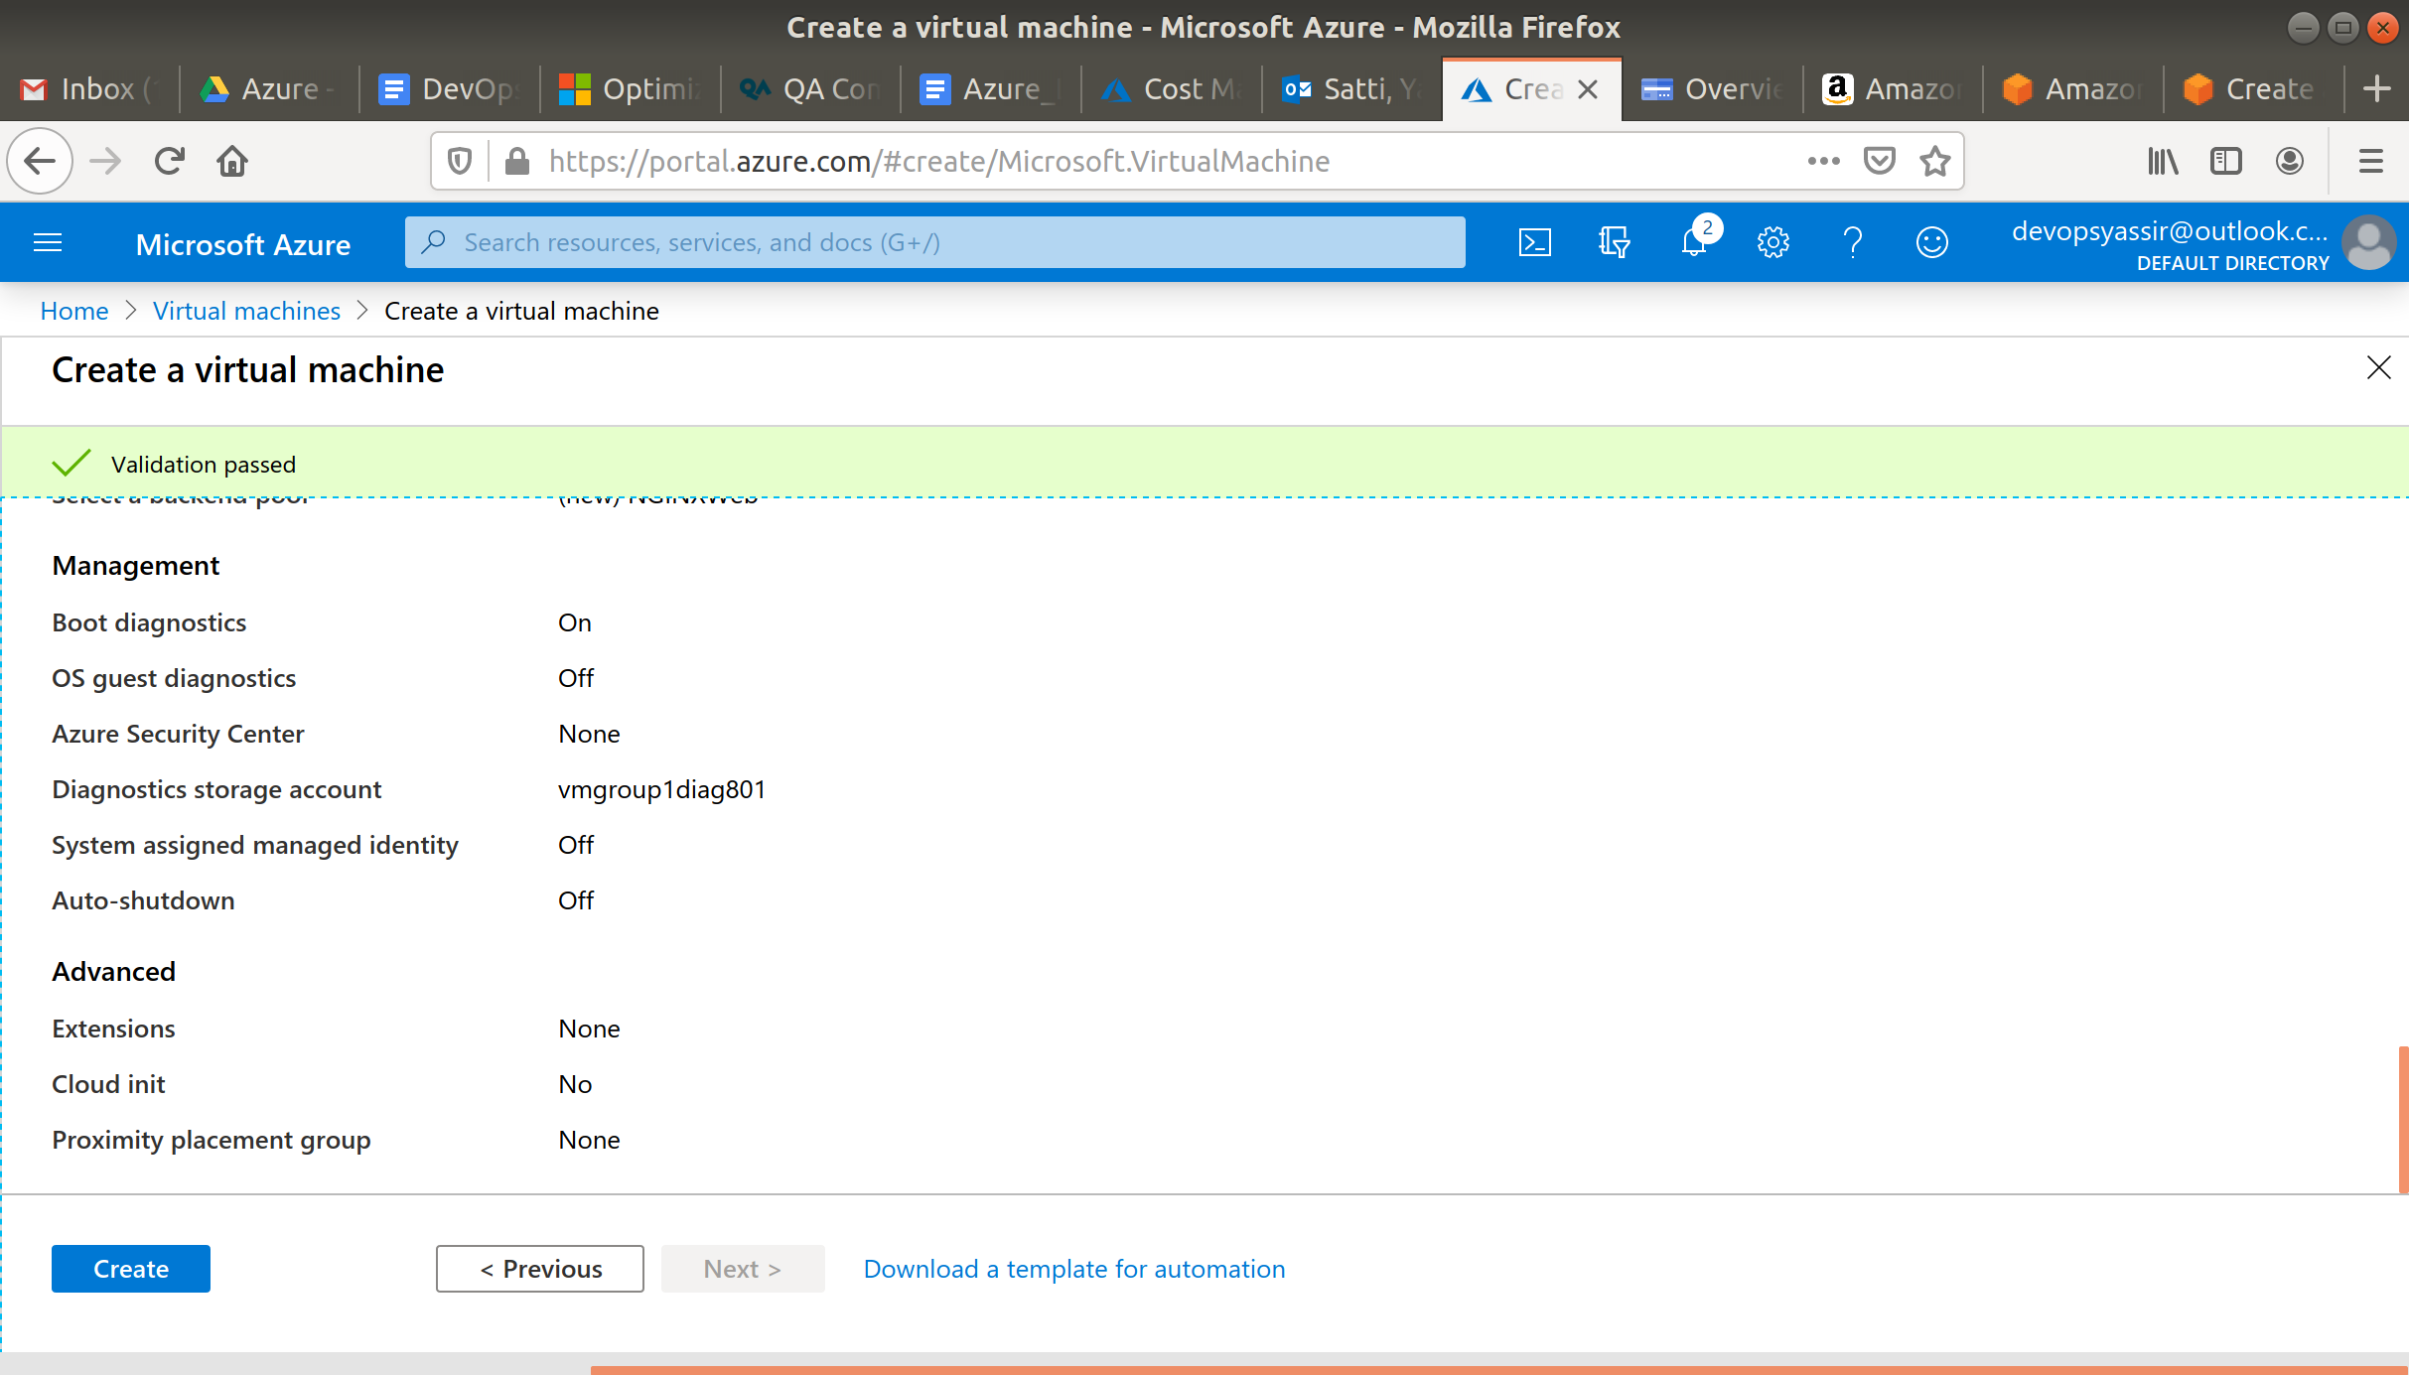

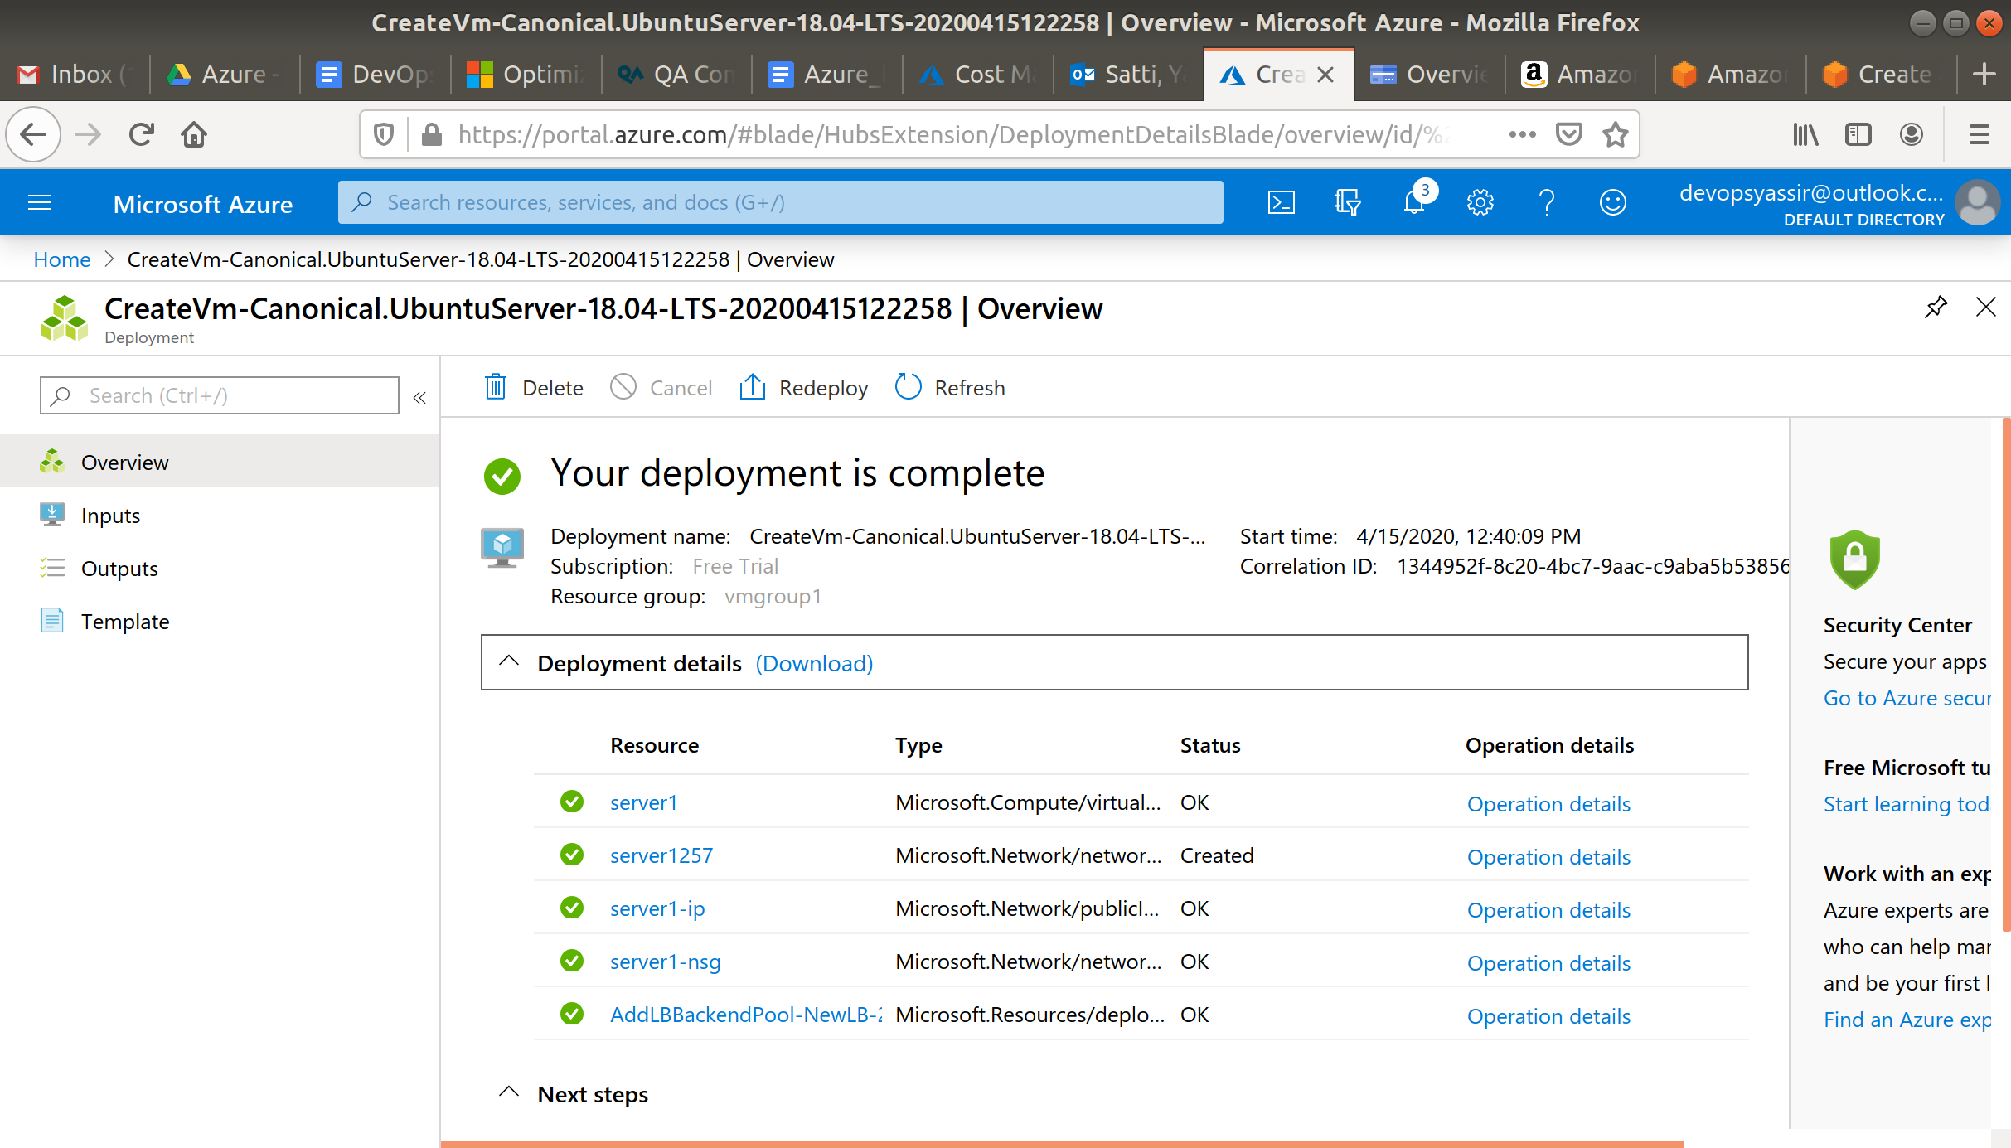

Add a second VM in the same way, but this time call it **server2**.

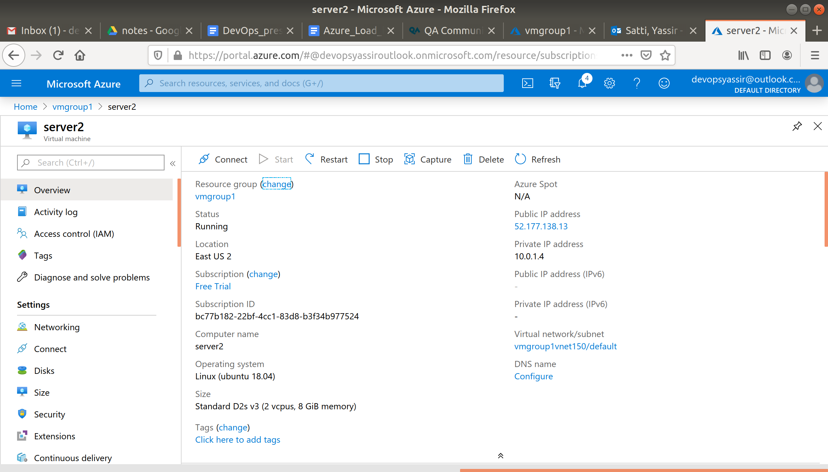

### **Creating the web apps**

SSH into server1.

Navigate to the server1 blade and click on connect.

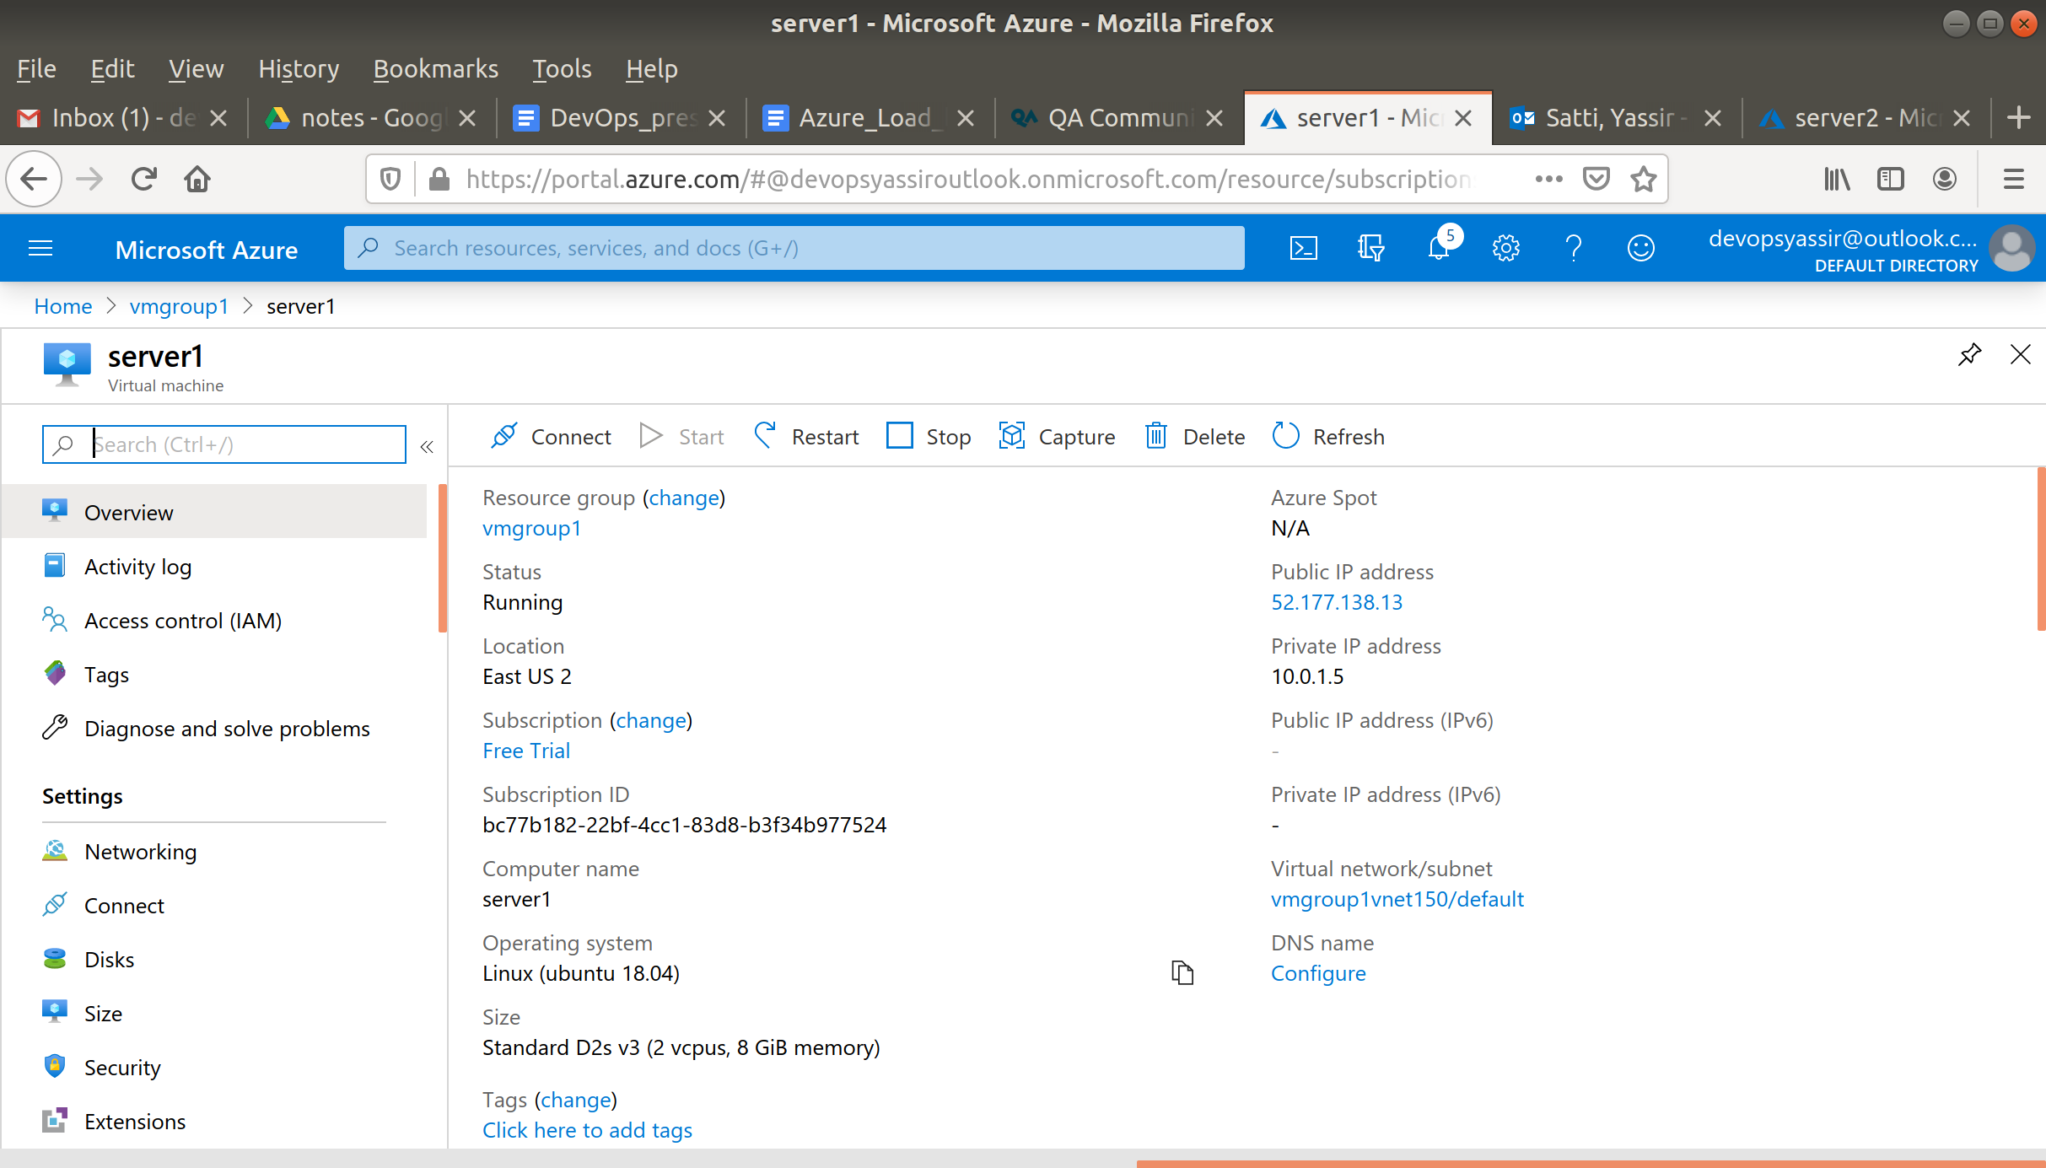

In the new blade, copy the Login using VM local account.

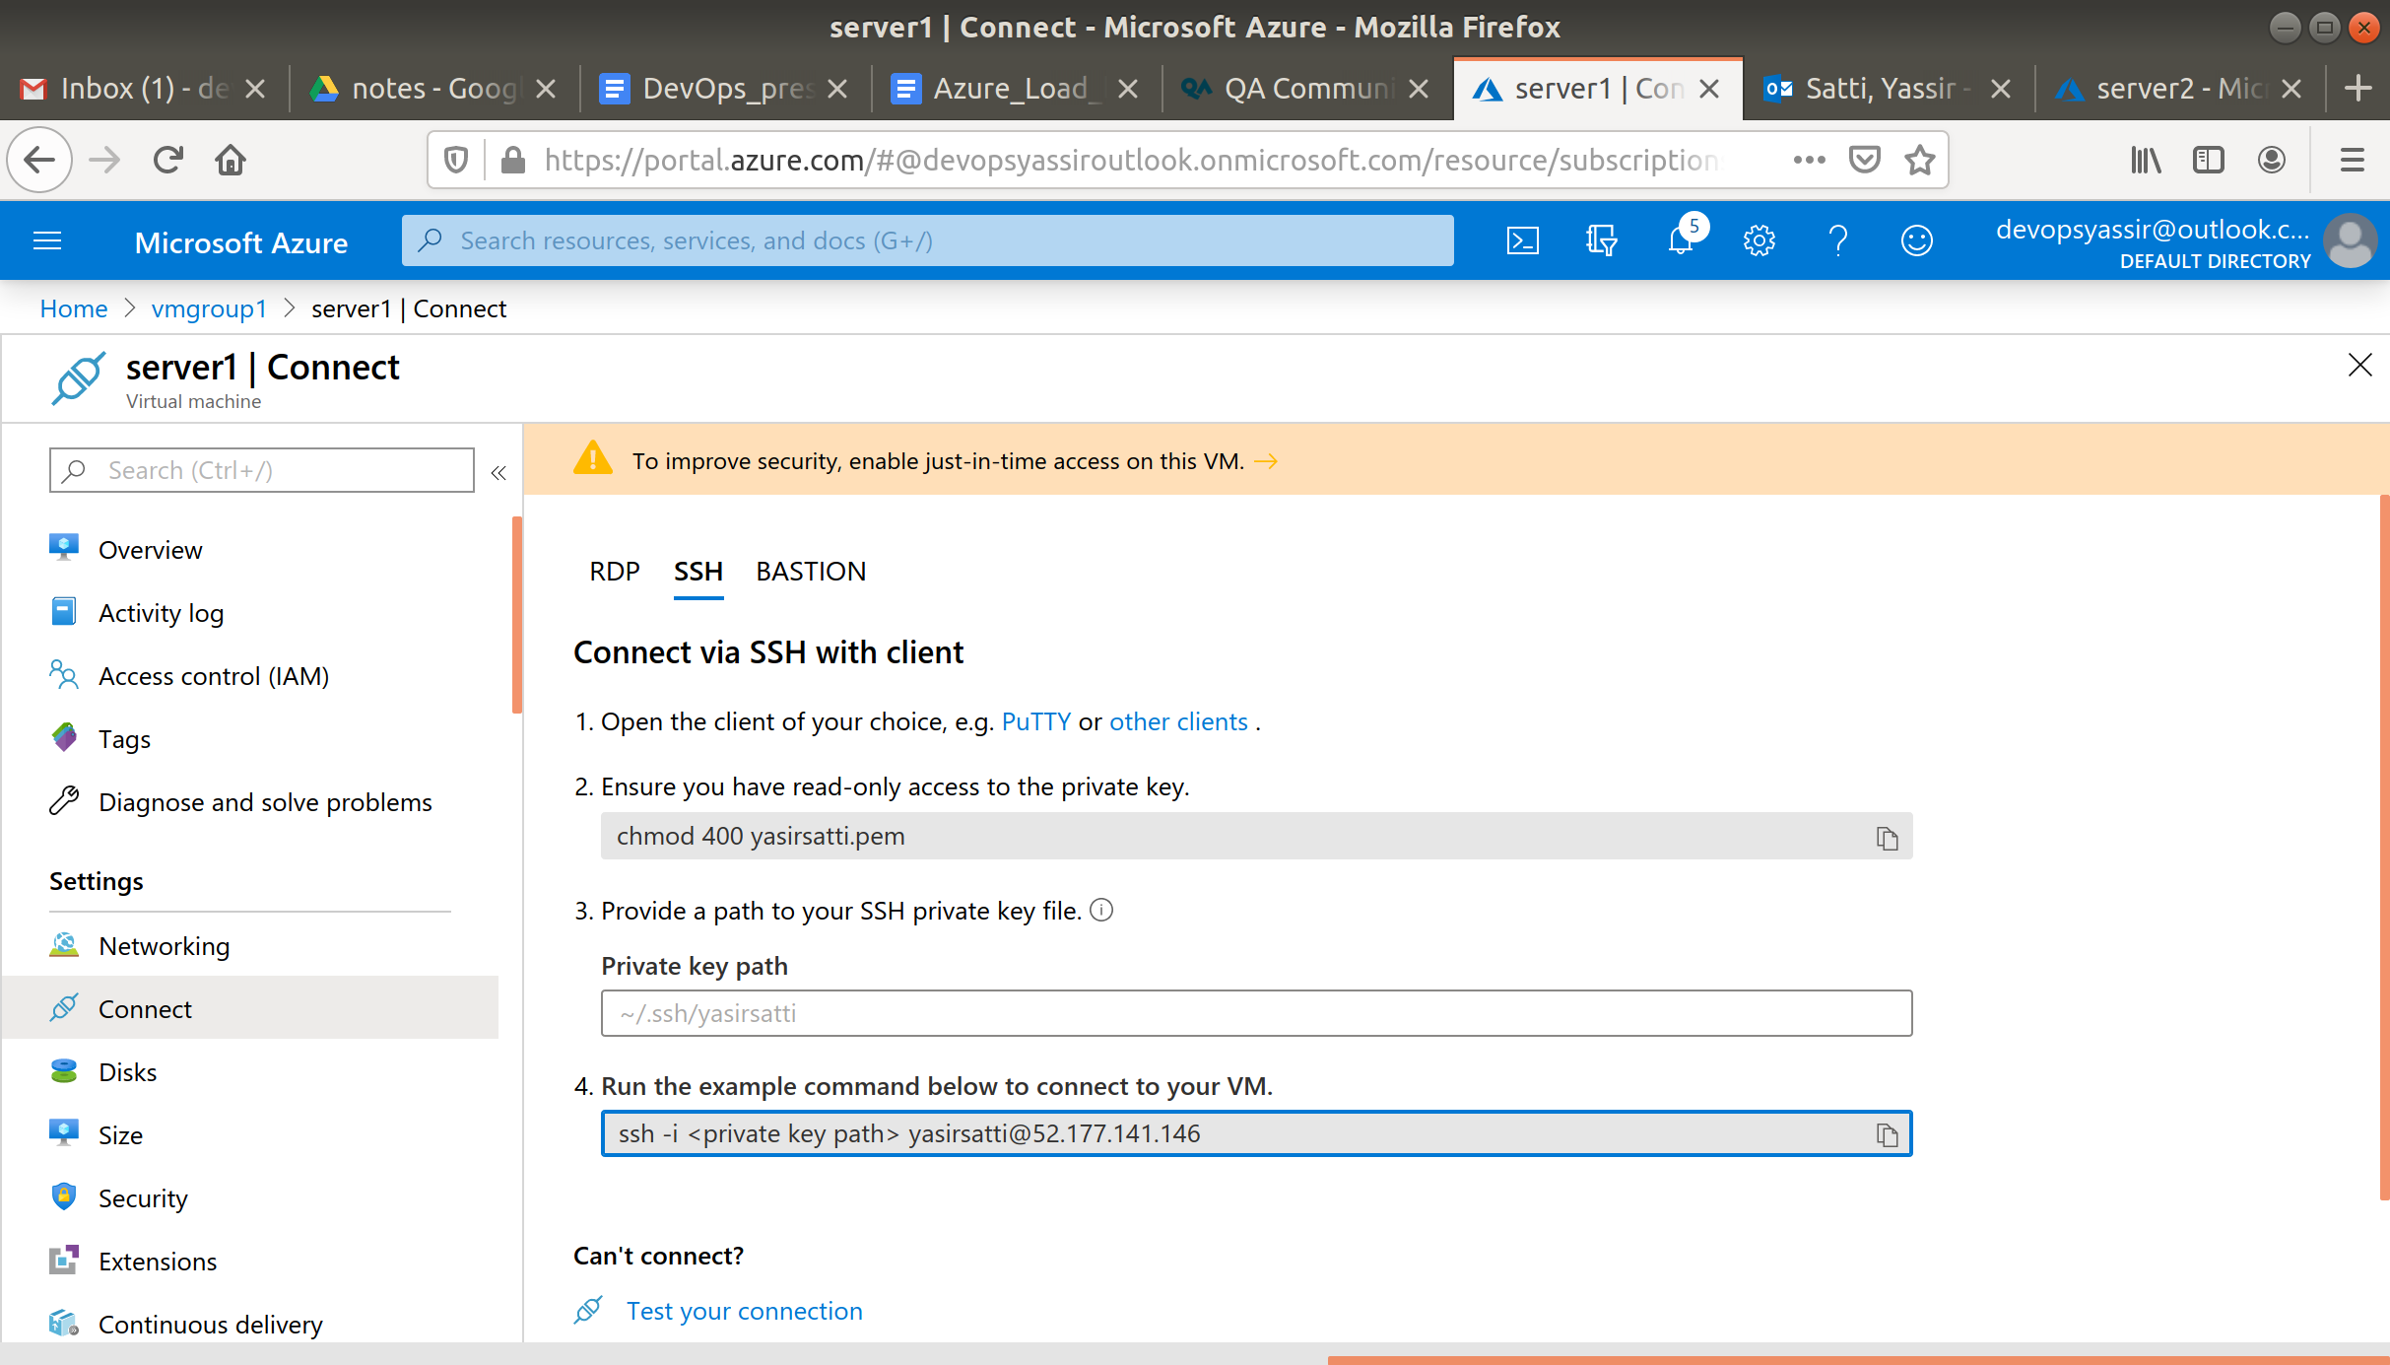

Then paste it in to either a powershell or in your Linux terminal.

Once you have connected, run the following commands:

**sudo apt update**

**sudo apt install nginx -y**

You will need to modify the **index.html** which is showing the NGINX homepage so that you can identify which server is going to be returned by the Load balancer. Run the following commands:

**$ sudo su**

**$ echo > /var/www/html/index.nginx-debian.html**

$ **nano /var/www/html/index.nginx-debian.html**

Paste the following in to the **html** file.

<html>

<head>

<h1>Hello Community!</h1>

<h2>This is our First Server</h2></head>

<body bgcolor="#98fb98">

</body>

</html>

Save and quit. Run the command:

**sudo service nginx reload**

Refresh the webpage for server1 and you should see it has changed.

Repeat the process for server2, but paste the following in to the **html** instead.

<html>

<head>

<h1>Hello Community!</h1>

<h2>This is our Second Server</h2></head>

<body bgcolor="#5DBCD2">

</body>

</html>

You should now have two different VMs serving up different NGINX home pages.

To see this we must first do some more configuration on the load balancer.

Navigate back to your Load Balancer which you created earlier. Click on Health Probes in the settings blade.

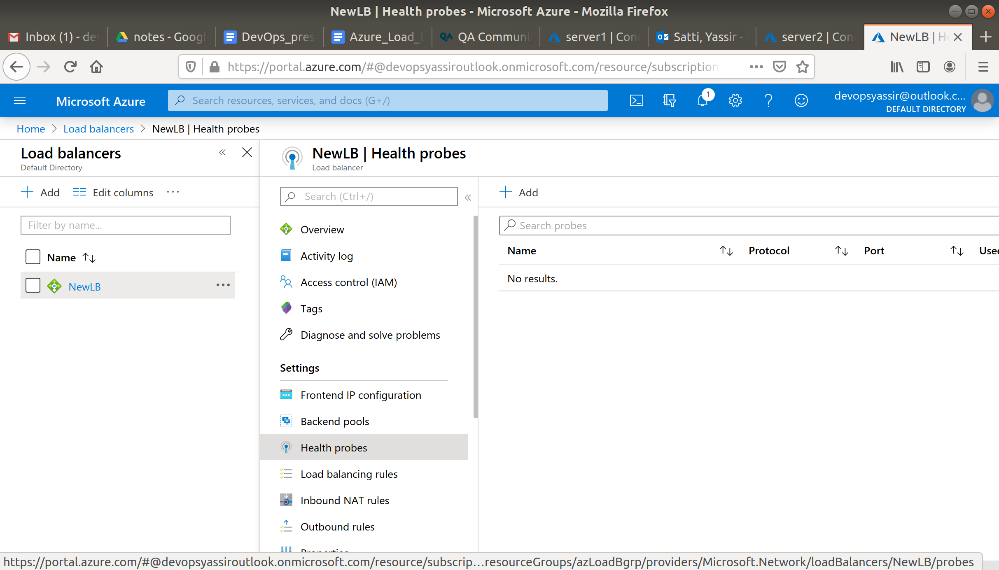

The click + Add, give the new health probe a name and leave the rest of the options as standard.

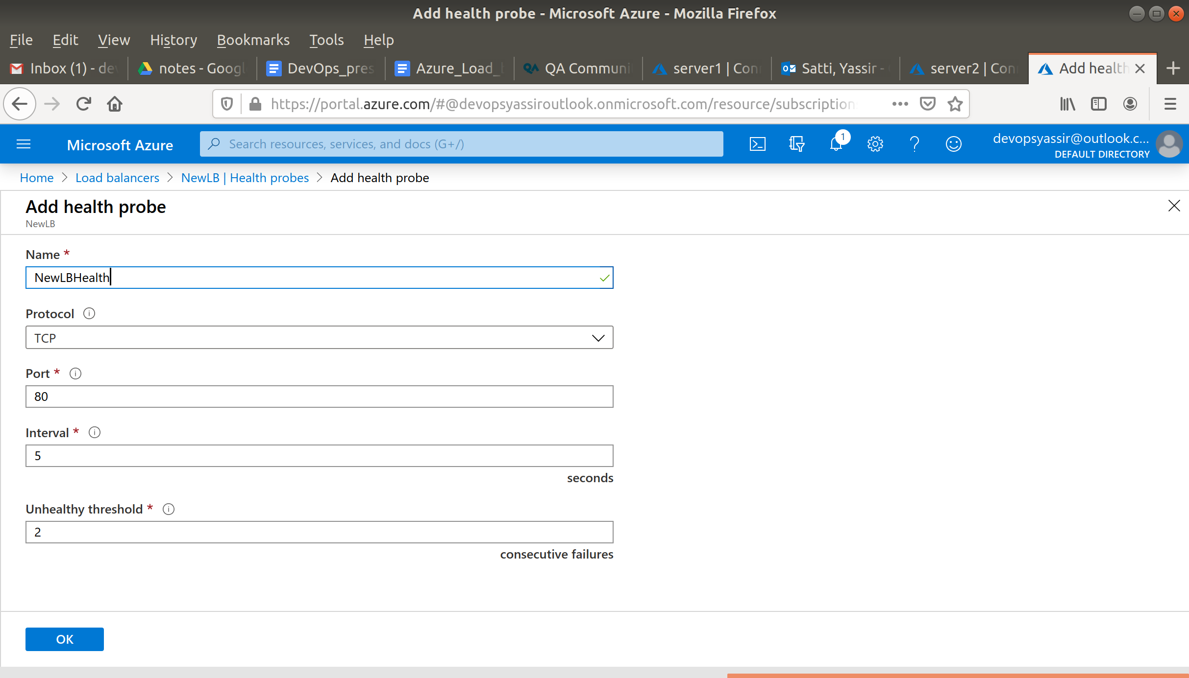

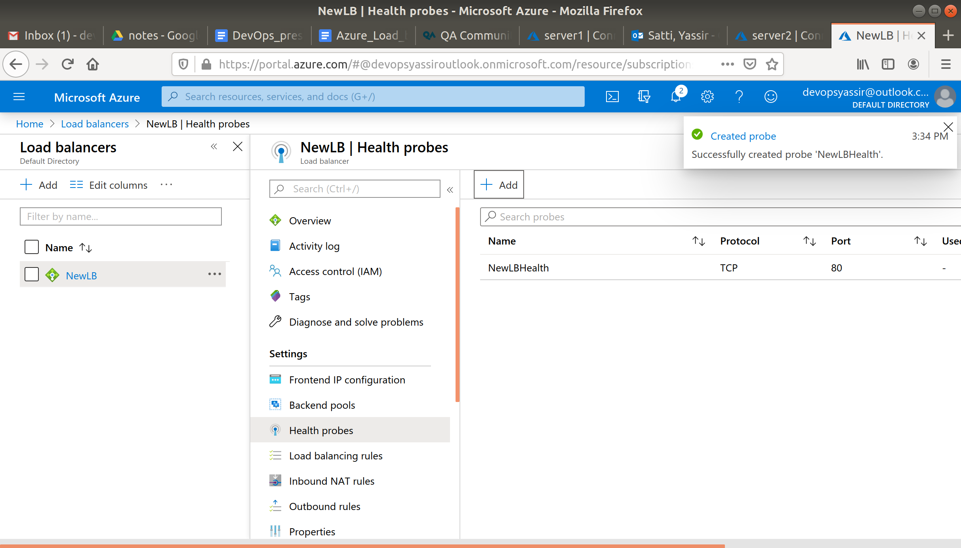

Then head to Load balancing rules, which is also in the settings blade.

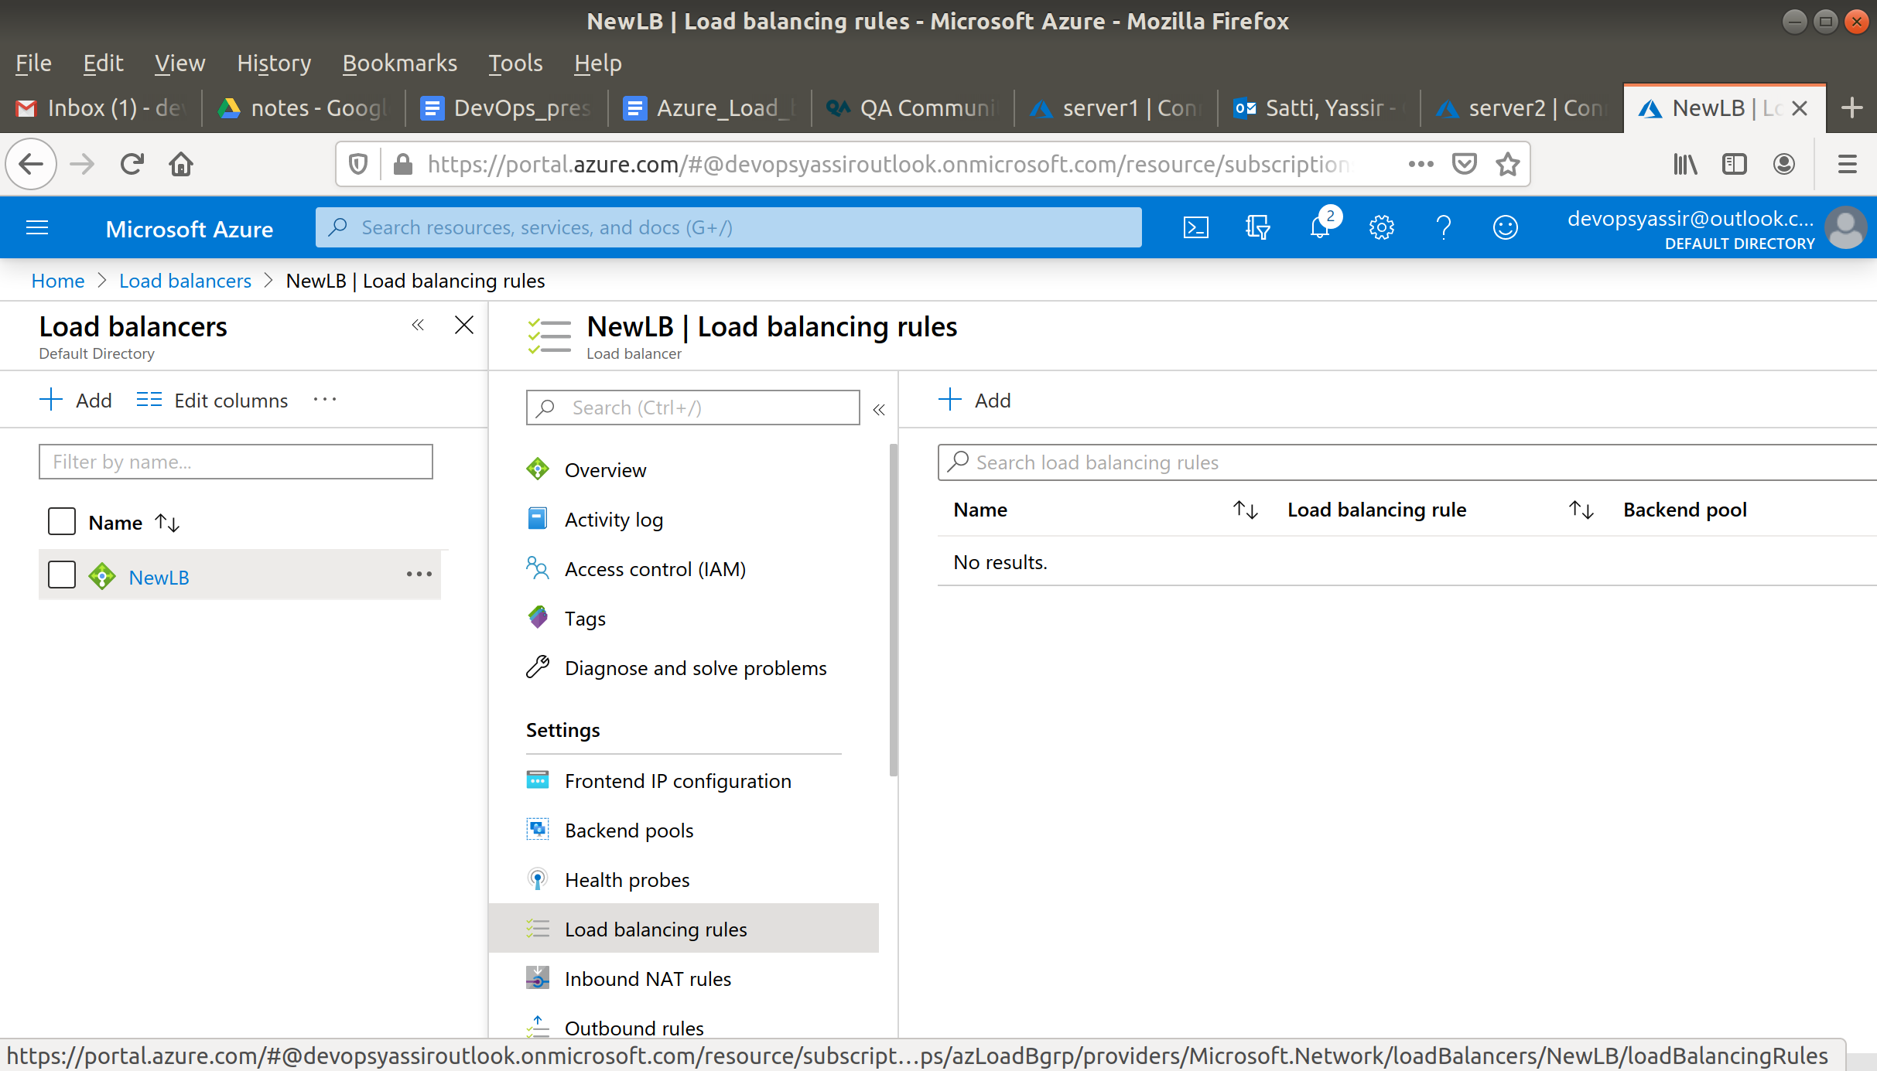

Click + Add, and you should see the following.

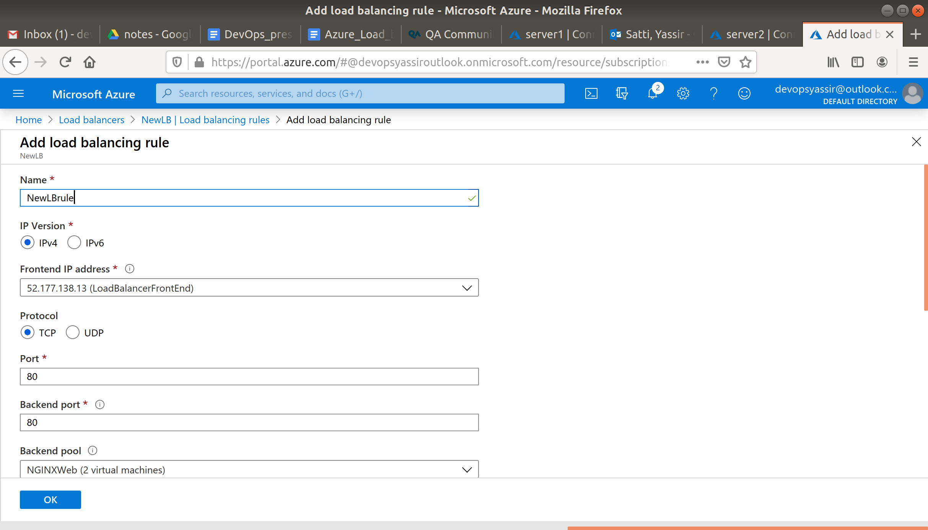

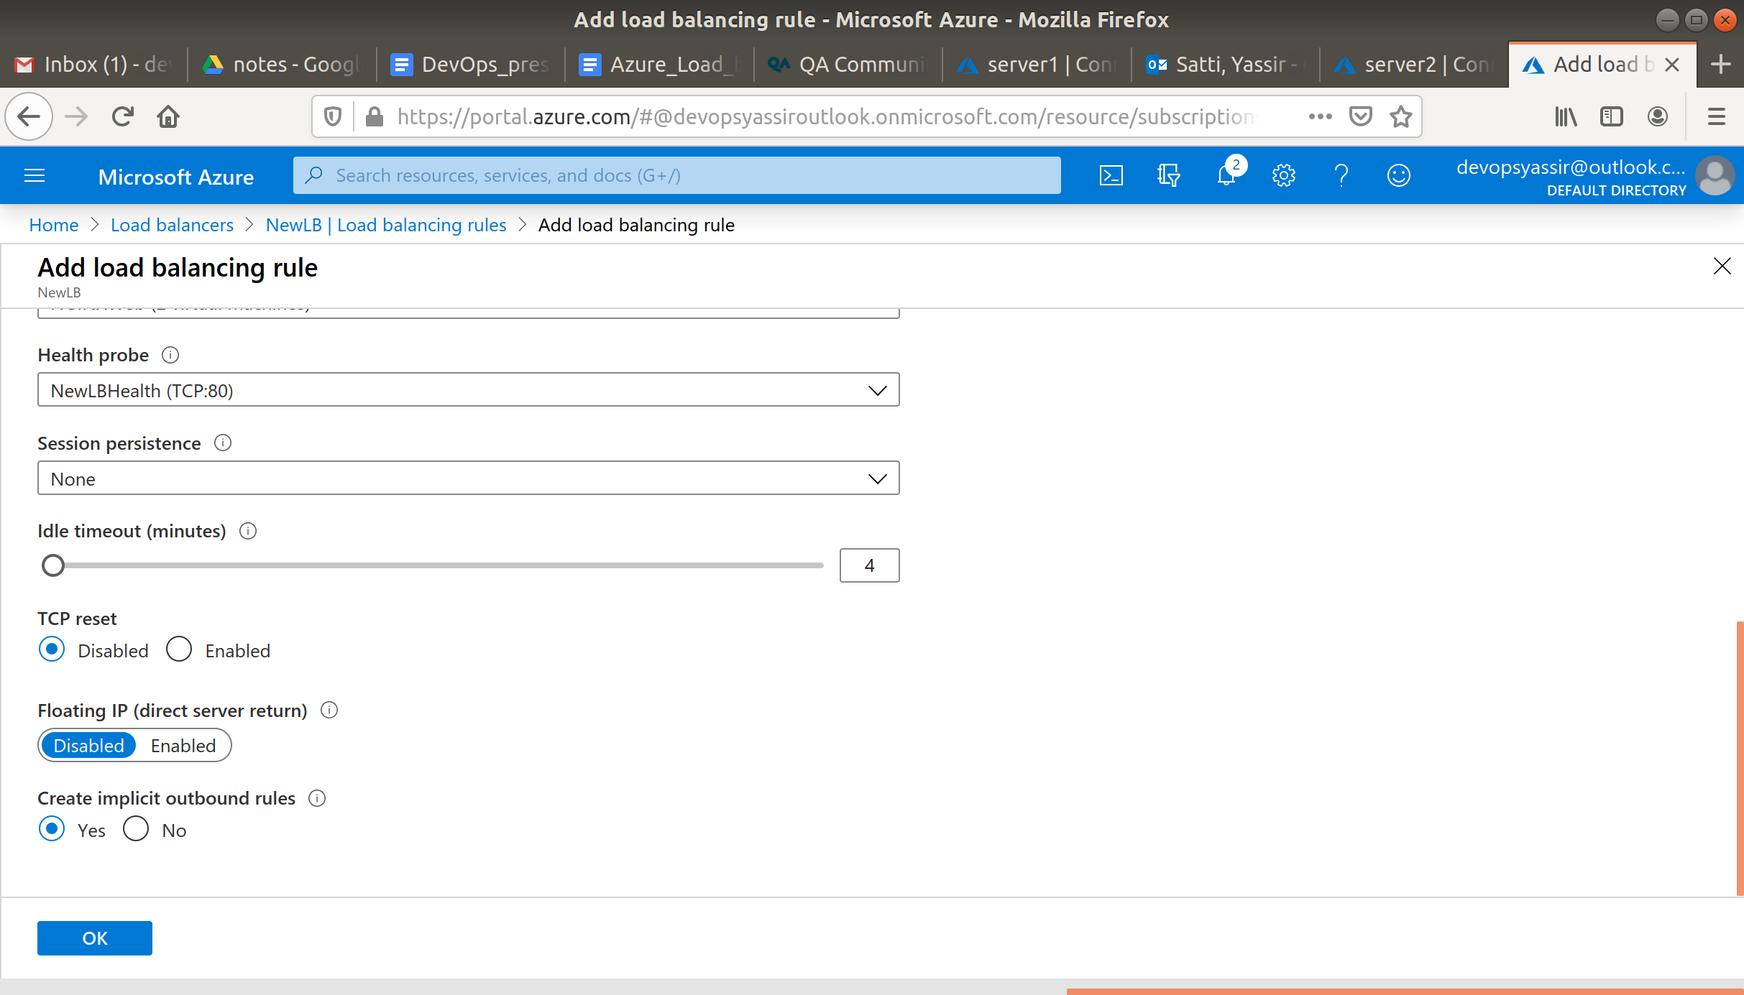

Give the rule a name and click OK.

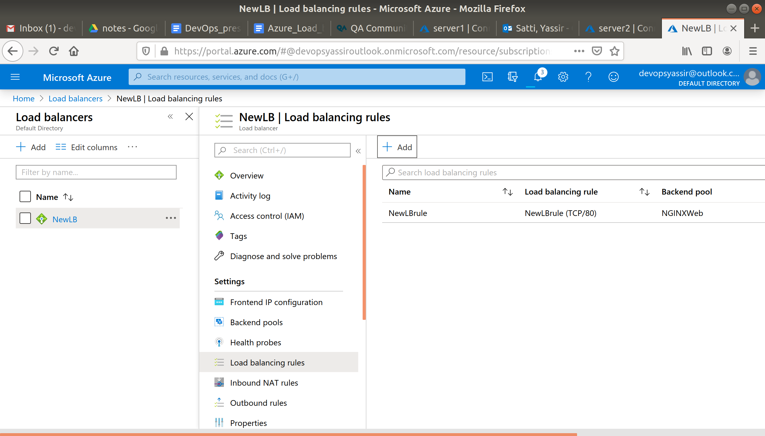

Once your rule is set up, head back to the overview of the Load Balancer, copy the public IP address of the Load Balancer and paste it in to your browser (without the IP name).

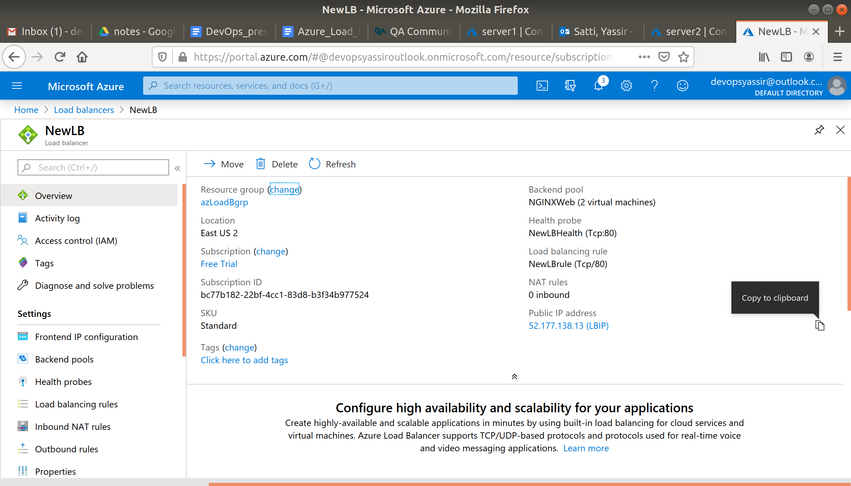

If you refresh the page quick enough, you will see that the webpage which is being served to you changes, but the IP address remains constant.

This is because the Load Balancer is distributing traffic between the two VMs we set up, and each VM has a slightly different HTML.

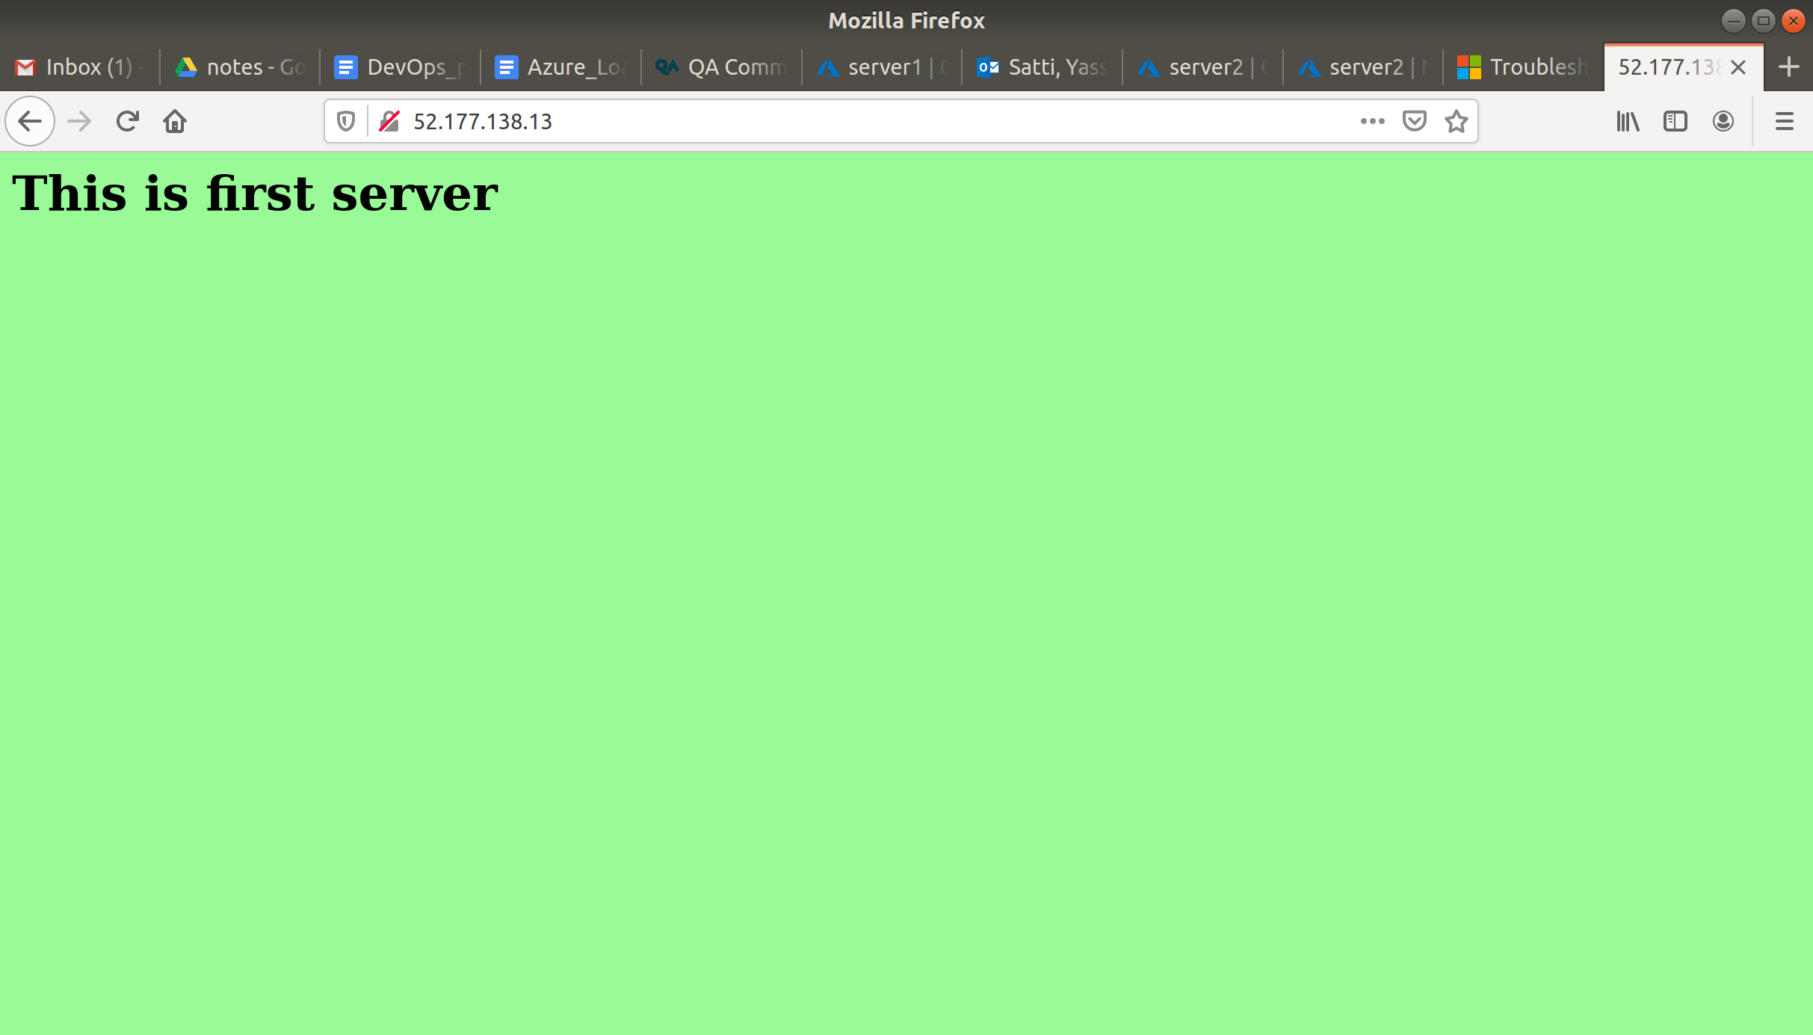

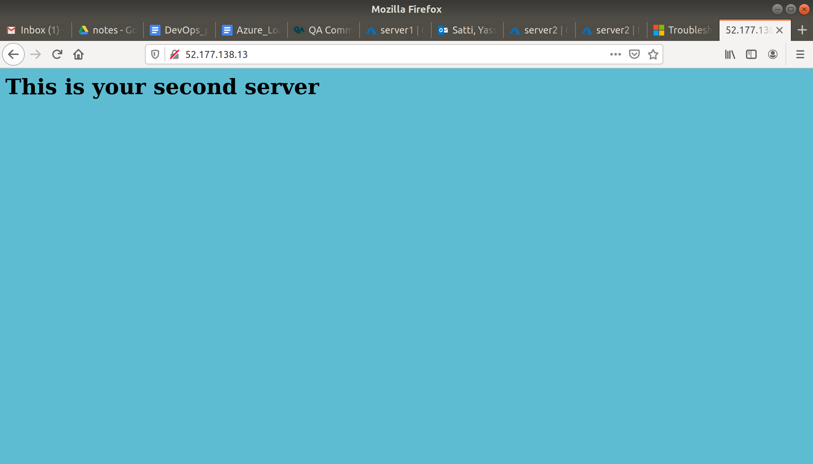

### **Clean Up**

To clean up, go back to the Resource Group page, click your resource group you used for this module, and then choose Delete.

Once you type the name of the resource group to confirm deletion, this will be deleted along with everything inside of it.